Zipf law and Luhn analysis 3
Text representation 4
One Hot Encoding (OHE) 🙁 4
Binary term-document weighting 🙁 5
Hand-crafted feature representation (dictionary/thesaurus) 🙁 5
Distributional model of meaning = vector-space models of meaning = vector semantics 6
Four kinds of vector model 6
Co-occurrence Matrices 7
Term-document matrix 7
Term-term matrix (word-word matrix) 7
Vector semantics: positive pointwise mutual information (PPMI) 8
PMI (Pointwise Mutual Information) 8
PPMI (Positive Pointwise Mutual Information) 😐 9
Weighting PMI 9
1. Give rare words slightly higher probabilities 10
2. Use add-one smoothing (Laplace smoothing) 11
Using syntax to Define word’s context 11
Alternative to PPMI for measuring association 12
TF-IDF ( 🙂 for word-document similarity, 🙁 for word-word similarity ) 12
Cosine similarity ( 🙂 for word-word similarity) 13
Language modelling 15
N-gram language modelling 15
Language Models (recap) 17
How to compute the probability of a sentence W, aka P(W) 17
Technical method 🙁 to compute the probability of a sentence P(W) 17
Practical method 🙁 to compute the probability of a sentence P(W) 17
Markov assumption 🙂 to compute the probability of a sentence P(W) 18
Problems of ngrams 19
Estimating Probabilities 20
Smoothing 20
Evaluate a model 20
Singular Value Decomposition (SVD) 😐 - A method for getting short-dense vectors 22
Word2vec 🙂- A method for getting short-dense vectors for word embedding that exploit local level information 24
CBOW (word2vec) (Continuous Bag Of Words) 25
Skip-gram (word2vec) 25
Example: skip-gram 26
Word2Vec - Skipgram model in details 26
Word2Vec - model of CBOW 27
Word embeddings - Embedding learning algorithms 27
GloVe 😐- a method for word embedding that exploit global level information 28
FastText 🙂 - a method for word embedding that exploit character level information 29
Properties of embeddings 30
Visualise word embeddings 30
Evaluate embeddings 31
Embeddings reflect cultural bias 31
Embedding Learning Algorithms 31
Sense representations: two branches 32
SensEmbed 🙂 - part of knowledge-based sense embeddings 32
SW2V🙂- part of knowledge-based sense embeddings 33
Contextualized word embeddings 36
N-gram language model part 2 37
Neural language model 37
How to build a neural language model 38
Fixed-window neural language model 🙁 38
Recurrent Neural Network (RNN) 😐 - predict the next word 39
ELMo🙂 (Embeddings from Language Models) - part of RNN used to compute the embedding of a word 40
BERT 🙂 (Bidirectional Encoder Representations For Transformers) - Use to predict next word 42
OOV (Out-Of-Vocabulary) words, a problem of Neural Language Model 43
Open vocabulary to fix the OOV problem 43
Back-off model 🙁 to fix the open vocabulary problem 43
Wishlist as another possible solution to the open vocabulary problem 43
BPE 🙂 (Byte Pair Encoding) - for word segmentation 43
Sequence generation - generate text 44
Sequence to sequence with attention 🙂 - for translation 45
More general definition of attention 47
Transformers 47
Self-attention in detail 48
Step 1 - calculate vectors 48
Step 2 - calculate the score 49
Step 3 & 4 - divide the score and softmax 49
Step 5 & 6 - multiplication of the softmax and sum of the weighted value vectors 49
Multi-headed attention: the beast with many heads 50
Representing the order of the sequence using positional encoding 51
Machine translation 52
Purposes of machine translation 52
Vauquois triangle 52
Direct translation 53
Transfer-based translation 53
Interlingua-based translation 53
Translation evaluation 53
Source-based human evaluation 😐 53
Adequacy 53
Fluency 53
General translation quality 54
Reference-based human evaluation 😐 54
Reference-based automatic evaluation 😐 54

Language:
- Is not stationary: we can invent new words over time and it will evolve with time
- Is ambiguous: it is open to interpretation. (Apple can be a fruit or the company). Given a context we can disambiguate, also ambiguity can appear to all levels (phonology, graphemics, morphology, syntax and semantics)
  - Syntactic ambiguity: they ate the pizza with anchovies. 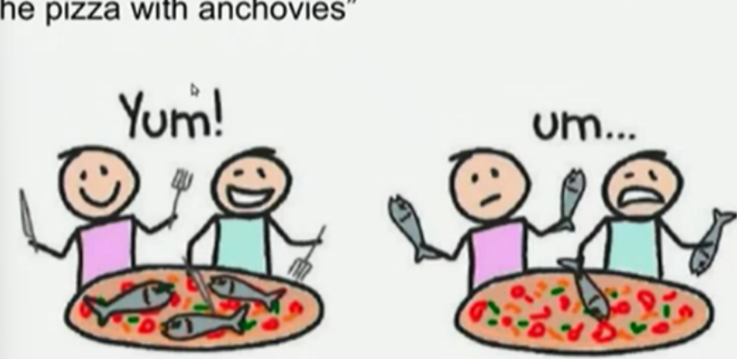
  - Semantic ambiguity:
    - Polysemy: a single word that has two (or more) meaning
    - Name entity: two entities (like two people) with the same name
    - Object/colour: cherry can be a colour or a fruit
- Pragmatic ambiguity: Mike will hear the car talk at noon. It is not the cars talking to each other. It is easy for humans to disambiguate, but it is hard for machines
- It varies at all levels: the variability of a language depends on a lot of factors (like social context, topic, geography…), examples of variations are in:
  - Phonetic (accent)
  - Morphological, lexical (spelling)
  - Syntactic (word orders differ across languages, and a single language can have different degrees of freedom)
  - Semantic

Zipf law and Luhn analysis
The product of the frequency [ f(w) ] of use of words and the rank order [ r(w) ] is approximately constant. So, the frequency of w, f(w), is proportional to 1/r(w)

$f ∝ \frac{1}{r}$
$or f × r = k (for constant k)$
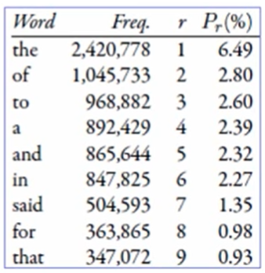
Basically we will get the same distribution of the words independently from the corpus that we are working with.

What is interesting is that if you count any single word in the corpus and you rank them by decreasing order of frequency, if you take the frequency and you multiply it by the rank you get roughly the same number for every word.
2420778 * 1 ≈ 1045733 * 2 ≈ 968882 * 3 ≈ …

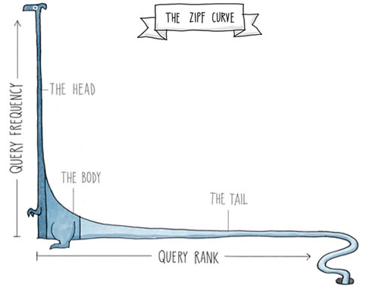
Head words: take large portion of occurrences (appear a lot), but they are semantically meaningless (the, of, a, an, we, do, to, for)

Body words: most important one, makes us able to discriminate the content of a document. Do not appear very often but they are also not very rare.

Tail words: have a small portion of occurrences (are very rare). (dextrosinistral)

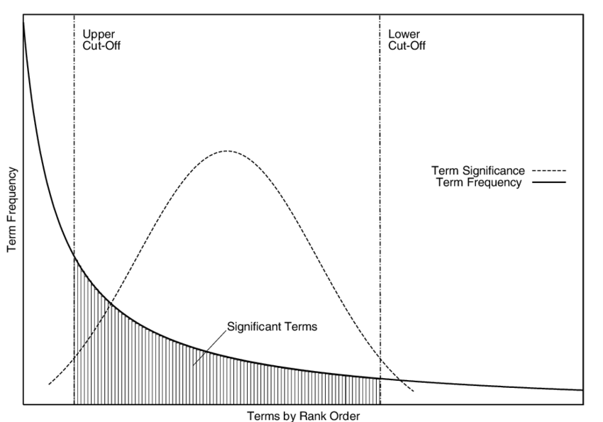
The ability of words to discriminate the content of documents is maximum in the intermediate (body words) position between the two cut-off levels. Not all words in a text describe the content with the same accuracy/informativity.

Text representation

Objective: given a vocabulary V of words w₁, …, w_{v} and a corpus D our goal is to associate each word with a representation. We want to represent the words in a way that a computer can understand. The representation should:
- Identify a word: (bijection between the word and the representation). The representation must identity a single word, and a single word refers to a single representation
- Capture the similarities of words (based on morphology, syntax, semantics, …). Apple and Tree are somehow similar
- Help us solve downstream tasks: if we want to build a conversation system this representation should be useful

(Note: vector-based representations of text are called embedding)

One Hot Encoding (OHE) 🙁
Is the traditional way to represent words, use a unique integer associated with each word. It is the most basic representation of any textual unit in NLP.

Problems:
- Not very informative: we consider movie and movies as independent entities.
- All words equidistant: movies and movies are located at the same distance of movie and cat. So there is no correlation encoded between different words
- Polysemy: mouse of the computer has the same vector of the animal

Binary term-document weighting 🙁
Example by incidence matrix
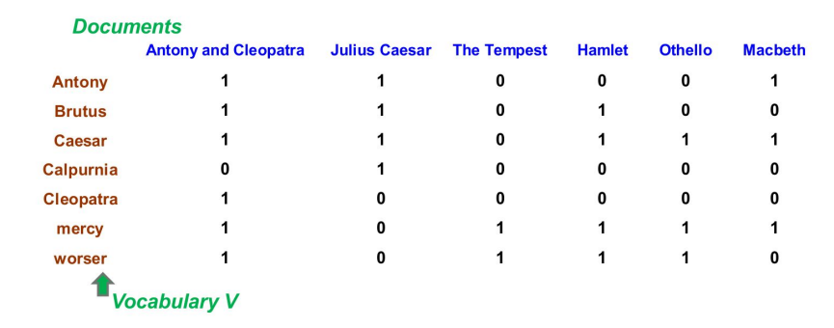
Note: it is called a term-document: the terms are the words (row) and the documents (the file) are the columns.

- Rows: all the unique words in all the document
- Columns: all the documents

- 1: if the word appeared in the document (independently if it appeared one or more times)
- 0: if the word was absent in the document

Each document D can be represented by a set of terms or by a binary vector € {0,1}^{|V|}, the binary vector will have the size equal to the number of unique words in the vocabulary.

Problems:
- We lose the information on how many times a word appeared in the document
- We ignore the position where a given word appeared in a given document (but it is not a big deal this one)
- We want something more informative, so that if we have fast and rapid it will tell us that the two words are similar. We want to include some correlation between the representation

Hand-crafted feature representation (dictionary/thesaurus) 🙁
We could use a dictionary to represent a word. In the dictionary we can specifies properties of a word like:
- Morphology: prefix, suffix, stern, …
- Grammar: part of speech, gender, number, …
- Shape: capitalization, digit, hyphen, …
- Relations to other words: synonyms of …, hypernyms of …, antonyms of …

(Note: a thesaurus is a book that provides synonyms, hypernyms and antonyms)

Problems:
- We do not have a thesaurus for every language
- We can not have a thesaurus for every year. For historical linguistic we need to compare word meanings in year t to year t+1
- Thesauruses have problems with recall: many words and phrases are missing
- Thesaurus work less well for verbs and adjectives
- A dictionary does not contains all the inflection of a word (you can not find canticchiavamo or mangerai)

Distributional model of meaning = vector-space models of meaning = vector semantics

Intuitions:
- Oculist and eye-doctor occurs in almost the same environments
- If A and B have almost identical environments we say that they are synonyms. By knowing the context we can infer which word is similar to which
- You shall know a word by the company it keeps

Distributional word representation in a nutshell
- Define what is the context of a word (is the entire paragraph, the entire document, 3 or 5 words before and after?)
- Count how many times each target word occurs in this context
- Build vectors out of (a function of) these context occurrence counts. It takes as input the word w and the context of a word X_{w} = f(w, Context(w))

First we need to define what is the context of a word and only after we can think on how to build the function f(w, Context(w)). The context of a word can be defined as:
- The surrounding words (left and right words): look 5 words on the left and 5 on the right
- All the other words of the sentence/paragraph
- All the words after preprocessing and filtering-out some words
.

Four kinds of vector model

Shared intuition: model the meaning of a word by embedding (aka represent) it in a vector space. The meaning of a word is the vector (of numbers) called embedding.

Sparse vector representations
- Mutual-information weighted word co-occurrence matrices
Dense vector representations
- Singular value decomposition (and Latent Semantic Analysis)
- Neural-Network-inspired model (skip-grams, CBOW)
- Brown clusters

Co-occurrence Matrices
- Term-document matrix: represent how often a word w occurs in a document D (just count the frequency of w inside a document)
- Term-term matrix: represent how often a word w_{i} occurs with another w_{j} (word-word co-occurrence matrix or word-context matrix)

Term-document matrix
Counts the number of times a word occurs in a document. Each document is a column count vector N^{v}. The matrix is V×D, where V is the number of unique words (vocabulary), while D is the number of documents.

- Row: words/terms
- Columns: documents
- In a cell: how many times a word (row) occurred in the document (column)

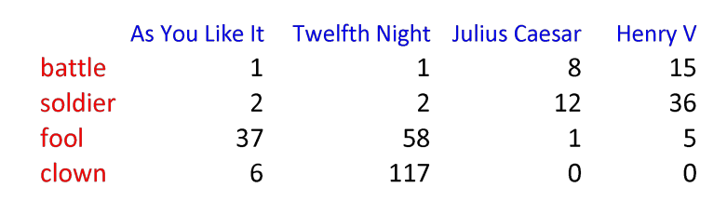
- Similar document: if the two vertical vectors are similar (like Julius Caesar and Henry V). These two vectors have length V (number of unique words)
- Similar words: if the two horizontal vectors are similar (like fool and clown). It has length D (document) because you need to check among all the documents.

Term-term matrix (word-word matrix)
It is slightly different from the term-document matrix. The column (before in term-document matrix were the documents), in term-term is now a smaller context. We can use as columns:
- Paragraphs
- Window of ± 4 words

In term-document matrix each horizontal vector was of length D (document) but in term-term matrix each horizontal vector is length |V| (vocabulary, number of uniques words)

We first define a context (in the example below ± 7 words)

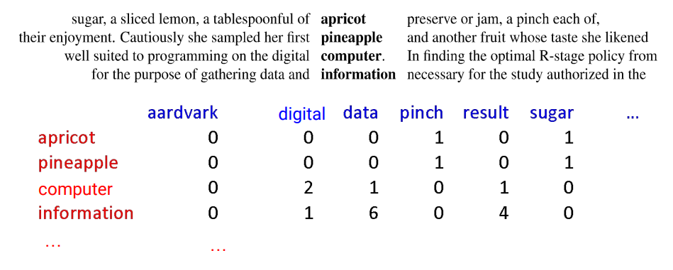
- Rows: target words
- Columns: context words
- In the cell: how many time the context word (column) appeared in the context of the word/term (row)

If the horizontal vectors are similar maybe the two words are close to each other (like apricot and pineapple)

(remember: you shall know a word by the company it keeps)

A real term-term (word-word) matrix is 50,000x50,000. It is very sparse (most values are 0). It is kinda ok because there are lots of efficient algorithms for sparse matrices.

Size of the window
- ±1-3 words of context (short window) ⟹ syntactic representation (the role of the word in a sentence)
- ±4-10 words of context (long window) ⟹ semantic representation (the meaning of the word in a sentence)

Vector semantics: positive pointwise mutual information (PPMI)
Raw word frequency (aka simply count how many times a word appears) is not a great measure of association between words.

As we saw with the Zip’s law, The and of are very frequent, but they do not carry significant semantic or contextual meaning.

Use Positive Pointwise Mutual Information (PPMI). It check whether a context word is particularly informative about the target word.

PMI (Pointwise Mutual Information)
(note: PPMI ≠ PMI)
Do events x and y co-occur more than if they were independent?

PMI between two words:

$PMI(word_{1},word_{2}) = log_{2}\frac{P(word_{1}, word_{2})}{P(word_{1})P(word_{2})}$

We compute the probability of two words appearing together divided by the probability of the two words appearing separately. Then we compute log₂ of the result

PMI ranges from -∞ to +∞ but the negative values are problematic, we do not need to go in the negative part. It is hard to give a meaning of unrelatedness.

⟹ replace negative PMI values by 0. If the result of the formula of PMI is negative we replace it with 0.

PPMI (Positive Pointwise Mutual Information) 😐


- Matrix: F
- Rows: W (words)
- Columns: C (context)
- f_{ij}: number of times w_{i} occurs in context c_{j}

We need to compute three distinct probabilities
- P_{ij} P(w,c): the intersection between the row and column of the two words of which we want to compute PPMI divided by the total number inside the term-term matrix
- P_{i*} P(w): is the sum of all the elements in the row [row vector] (the first of the two words needed to compute the PPMI) divided by the total number inside the term-term matrix
- P_{*j} P(c): is the sum of all the elements in the column [column vector] (the second of the two words needed to compute the PPMI) divided by the total number inside the term-term matrix

Weighting PMI

PMI is biassed toward infrequent events. Very rare words have very high PMI values [for example before sugar appeared as context of apricot 1 time, but it has a PPMI of 2.25 (the highest one)], we have two possible solutions:
- Give rare words slightly higher probabilities
- Use add-one smoothing (Laplace smoothing)

Both are fine and have similar effect, you can choose which one to use

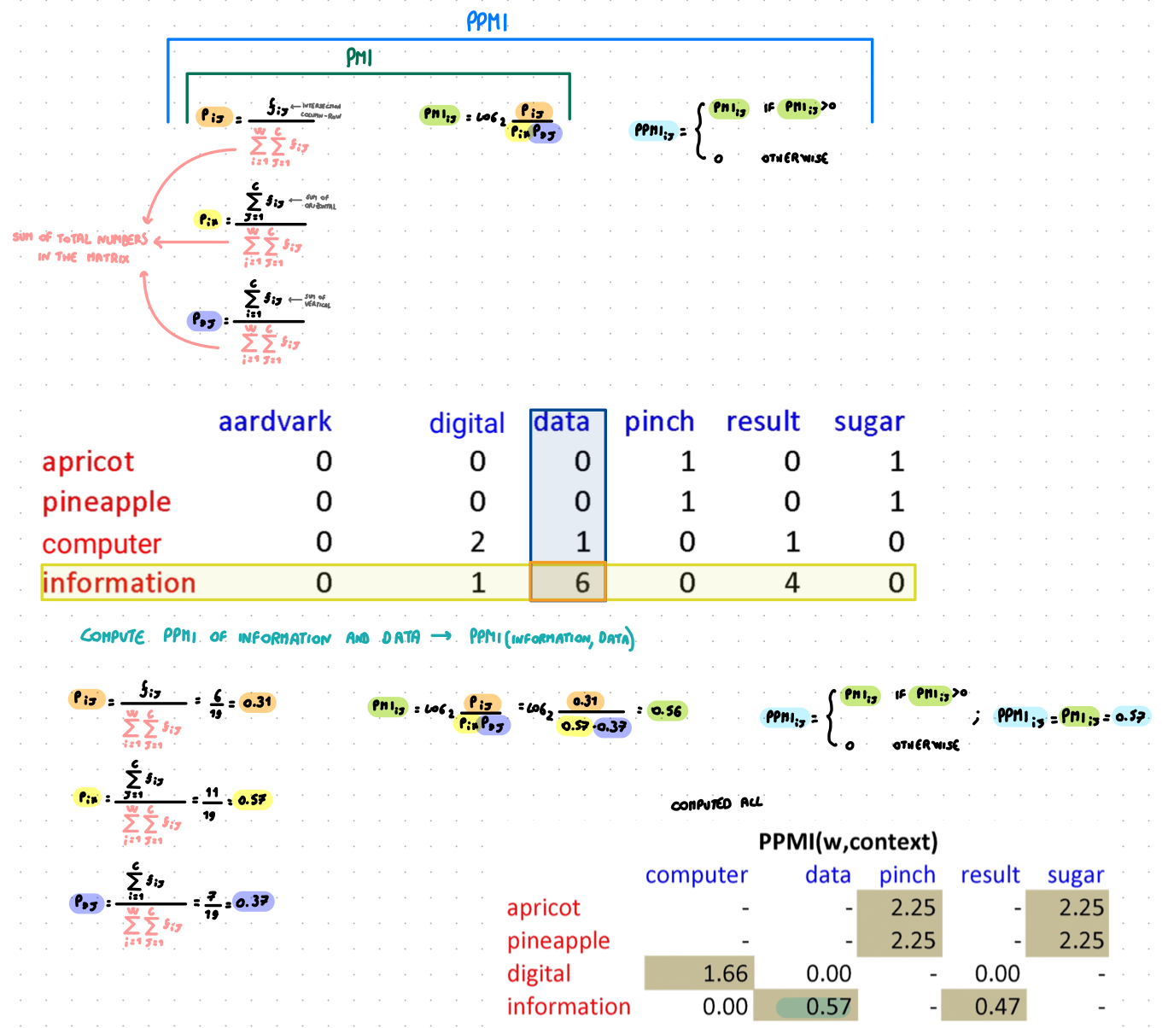
1. Give rare words slightly higher probabilities

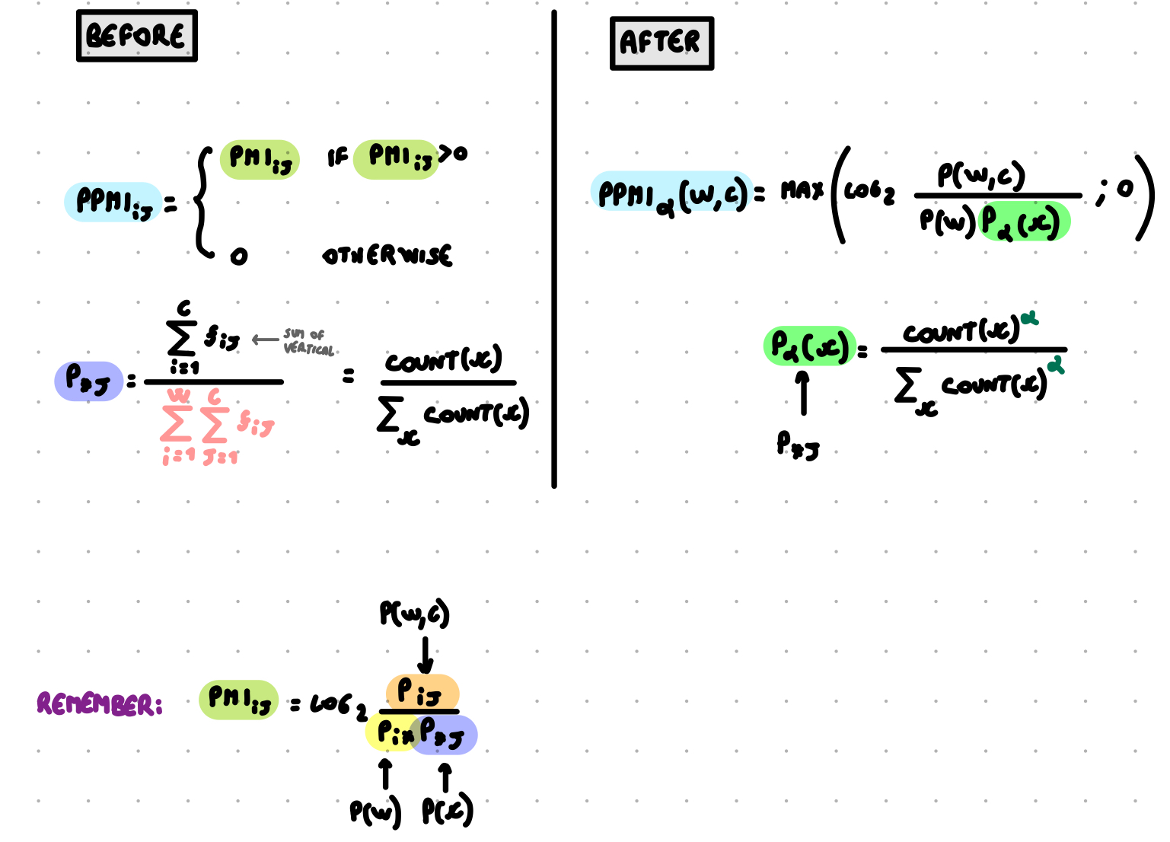

Usually α = 0.75

We use the same formula as before but when we compute P_{*j} [ P(c) ] (that is the context probability) we raise it to α

2. Use add-one smoothing (Laplace smoothing)
Before computing PMI_{ij} we add a small constant k (values from usually k = 2) to each of the counts.

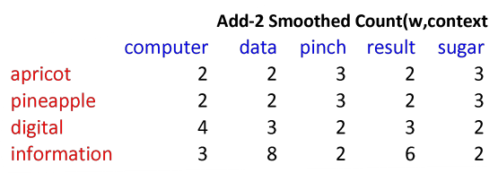
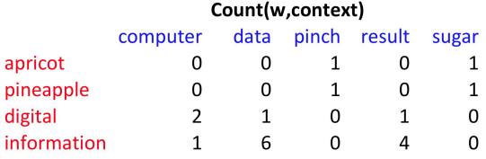

⟹ add 2

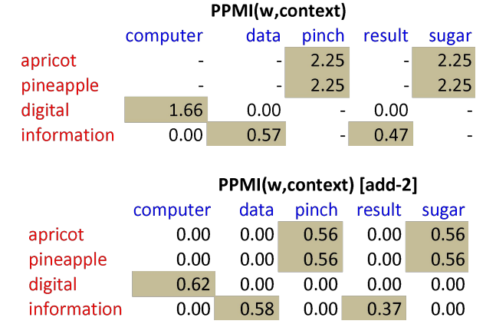


⟹ we get

Using syntax to Define word’s context
Two words are similar if they have similar syntactic contexts. Duty and responsibility have similar syntactic distribution.

Instead of continuing how many times a word appears together with another one (context) you can count how many times a word appears as an object or subject of a particular verb.
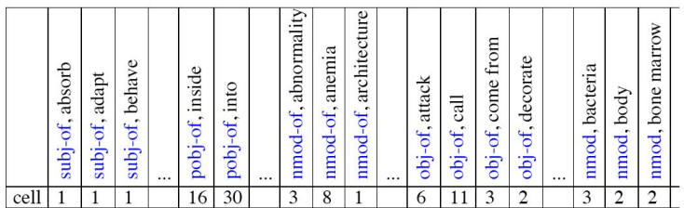

(example for the word cell)

Instead of a vector of |V| features, we have a vector of R|V| (R: grammatical relations like subject, object…)

(Remember: |V| is the vocabulary, number of unique words)
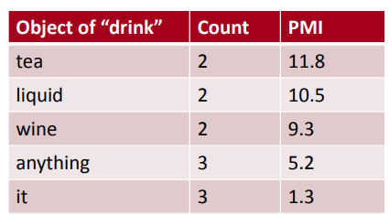

Drink it is more common than drink wine, but wine it is a better “drinkable” thing than it.

Syntactic dependencies for dimensions

Instead of having |V| x R|V| matrix we have a |V| x |V| matrix

But the co-occurrence counts aren’t just counts of words in a window, but counts of words that occur in one of R dependencies (subject, object, etc)

M(“cell”, “absorb”) = count(subj(cell,absorb)) + count(obj(cell,absorb)) + count(probj(cell,absorb)), …

Alternative to PPMI for measuring association
PPMI (Positive Pointwise Mutual Information) is a good measure, but there are others too.

Problem: cherry and pie might appear together a lot of time and they might be important. But also the and cherry appear together multiple times but they are definitely not important as cherry and pie.

TF-IDF ( 🙂 for word-document similarity, 🙁 for word-word similarity )
It combines two factors
- Term frequency: the frequency of a word. How many times a word i appears in a document j.
- Inverse Document Frequency (IDF): is the logarithm of the division of the total number of documents N and the document frequency of a word df_{i}

$idf_{i}=log_{10}\left(\frac{N}{df_{i}}\right)$
N: total number of documents
df_{i}: document frequency of word i, that is the number of documents where word i occurs

$w_{ij}= tf_{ij} idf_{ij}$
w_{ij}: word i in document j
tf_{ij}: the raw count of the word i in the document j

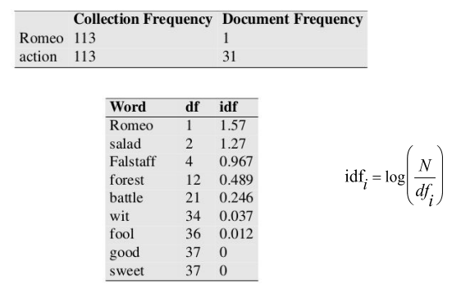

Document frequency of a term is the number of documents a term occurs in.

Romeo and action both appear 113 times. But they have very different document frequency: Romeo only occurs in one document, while action appears in 31 documents.

The fewer documents the word i appears the higher the idf_{i}. We can see that the idf is higher with Romeo and salad that appears in few documents (respectively 1 and 2), while fool, good and sweet appears in so many documents that are highly non-discriminative.

We can use as a document anything we want (also a paragraph can be a document for tf-idf).
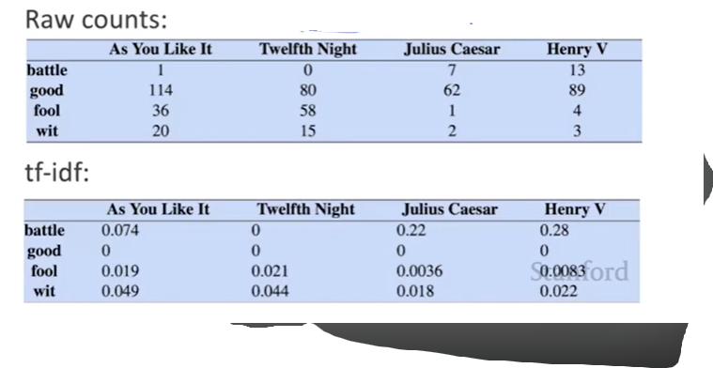

It is important to understand that we have a tf-idf for each document. It is not just a single tf-idf for all the documents.

Words like good appear a lot of time in different documents and so the raw count (aka the frequency) is bigger, but the inverse document frequency is smaller because good is present in a lot of different documents. So the tf-idf is 0 because the word can be considered to be meaningless, it is not useful to discriminate the document.

Tf-idf is not generally used for word-word similarity (since we compare words to documents). But is by far the most common weighting when we are considering the relationship of words to documents.

Cosine similarity ( 🙂 for word-word similarity)
Measure similarity between two words. Vector 4 Cosine Similarity

Given 2 target words v and w we need to find a way to measure the similarity of v and w. Most measures of vector similarity use the dot product (aka inner product) of linear algebra. Basically, we compute the products of the components of the word v and w on all the axes (aka the dimensions of the vector) and then we sum all those products together.

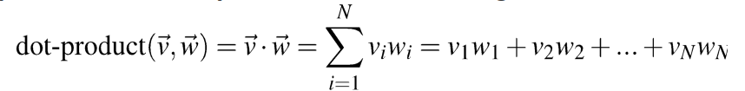

The dot product is:
- High when the two vectors have large values in same directions
- Low (actually is 0) for orthogonal vectors, with zeros in complementary distribution

Problem with the dot product
- Is higher if the vector is longer
- More frequent words (the, of, you) have longer vectors since they tend to occur many times with other words
- We want something that tells us if two words are similar, regardless of their frequencies

Cosine similarity
Just divide the dot product by the length of the two vectors. This is the cosine of the angle between the two vectors ( because $\vec{|a|}⋅\vec{|b|}$ = $\vec{a}⋅\vec{b}$ cosθ )

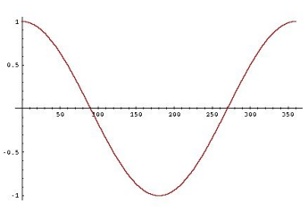
$\frac{\vec{a} ⋅ \vec{b}}{|\vec{a}| |\vec{b}|} = cosθ$

The cosine ranges between -1 and +1.
- -1: if the vectors points in opposite direction
- +1: if vectors points in the same direction
- 0: if the two vectors are orthogonal

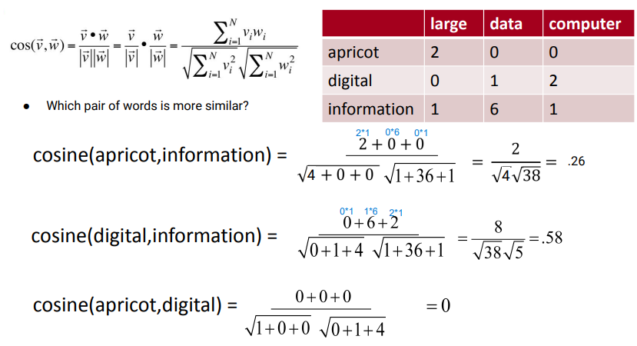$cosine(apricot, information) =\frac{sum of (apricot element * respective information element in the same column)}{\sqrt{squared apricot line} ⋅ \sqrt{squared information line}}$

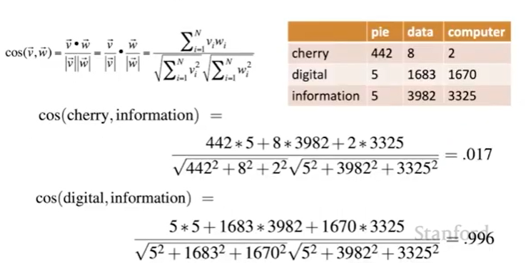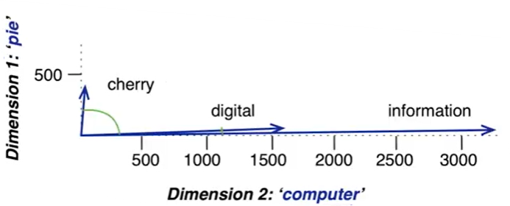

Lecture 9

Python file

Language modelling
Our task: build a language model that given a sequence of words (the context), it predicts what comes next (it is like a predictive text). We will never know for sure what comes next (we can not predict the future) but we can still make good guesses. We want a system with the best guess possible.

I want to ___ ⇐ we can restrict to just verbs, some verbs are more used than other
The capital of Italy is ___ ⇐ there is only one correct answer. All the other are wrong
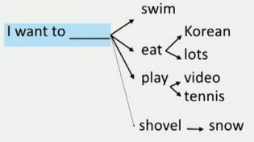

I want to shovel snow is grammatically correct but is less likely then I want to eat Korean or I want to play tennis.

N-gram language modelling
N-gram: a sequence of n words

Main idea: collect statistics about how frequent different n-grams are and use these to predict the next word.

It predicts the next word based on the previous n-1 words. (can be bigram, trigram, …)

A n-gram language model is a conditional probability distribution

P(next word = y | previous word = x)
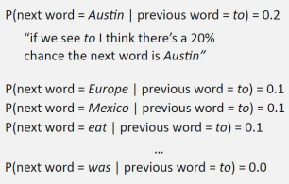

All these probabilities must add up to 1 over the vocabulary (every possible word y could be).

We assumed a fixed vocabulary of ~30,000 words. (First we need to decide how many words are in a vocabulary)

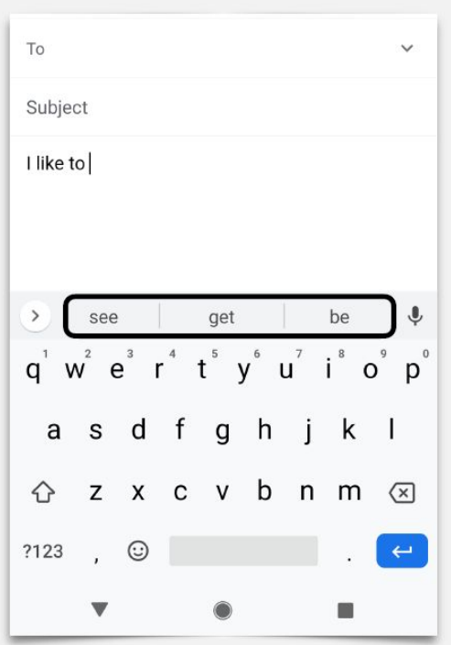

If we have all the probability of all the words then we can build the predictive text system (ngram). It picks the one word (or three words in the example) that are more likely.

The probability are learned from the data. We have lots of text data, we learn all the probability and then we can apply it to our system. The most important step is the estimation (aka how the probability are actually computed)

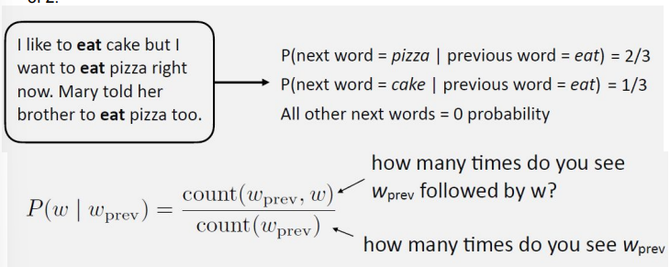
We consider thousands of possible outcomes (different words, vocabulary size) instead 2.

We count the probability of a word given the previous one, and we count how many times the words appear together in exactly that order and then we divide by the number of times the context word appears in the text.

As an example, if I want to predict the probability of the word pizza to appear after I want to eat … I need to count how many times the sentence I want to eat pizza appears in my corpus and divide it by how many times I want to eat appear in my corpus.

Problem: all other words have 0 probability to appear, this is not good. If in my corpus the sentence I want to eat ravioli never appeared then the probability that ravioli will be the next word after I want to eat … is 0. We want to assign some small probability to all the words, aka we want to smooth the distribution. We can use a unigram to smooth the probability

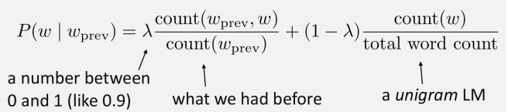
The probability of having the word and the context together + the probability of having the word by itself

If I do this now even if the sentence I want to eat ravioli never appears but ravioli is present (in a different sentence) inside the corpus then ravioli will have a probability to be chosen as the next word of the sentence I want to eat, this is because now we will take into account the fact that the word ravioli is inside the corpus.

Language Models (recap)
A language model is a model that assigns probability to sequences of words. Given a sentence we can ask the model what is the probability for the sentence to occur.

Words that tend to occur often when discussing a topic will have high probabilities in the corresponding language model.

A language model can have different applications, such as:
- Text categorization: categorise the topic of a text. If basketball appeared 3 times and game one in the article it is more likely that the article is talking about sport rather than politics

Notation
- The probability of a particular random variable X_{i} taking on the value “the” is P(X_{i} = “the”), we will use the simplified notation P(the)
- A sequence of n words is denoted by w_{1, …,} w_{n}, we will use the simplified notation w₁^{n}
- The joint probability of each word in a sequence having a particular value P(X = w₁, Y = w₂, Z = w₃, W = w_{n}). It is denoted as P(w₁, w₂, …, w_{n})

P(w_{n}|w₁, w₂, …, w_{n-1}) ⟹ (example) P(the | its water is to transparent that) to compute we need to calculate $\frac{C(its water is so transparent that THE)}{C(its water is so transparent that)}$ that is: count the number of times we see its water is so transparent that and count the number of times it is followed by the.

It is not true that if I increase the ngram I can build a better system. It is not always the case and there are many complex sentences, use at most 5grams (no more), it is suggested to use 3gram.

How to compute the probability of a sentence W, aka P(W)

Technical method 🙁 to compute the probability of a sentence P(W)
Technical method🙁: if you wish to compute the probability of a sequence of words W like its water is so transparent we would ask out of all possible sequences of five words, how many of them are its water is so transparent?, to do so we would have to get the count of its water is so transparent and divide by the sum of the counts of all possible five word sequences ⟹ it is a lot to estimate 🙁

Practical method 🙁 to compute the probability of a sentence P(W)
Practical method 🙁: we use the chain rule of probability.

P(x₁,x₂,x₃,…,x_{n}) = P(x₁)P(x₂ | x₁)P(x₃ | x₁,x₂)…P(x_{n} | x₁,…,x_{n-1})

That is,
P(its water is so transparent) = P(its) × P(water | its) × P(is | its water) × P(so | its water is) × P(transparent | its water is so)

It is better then the technical method but we can approximate even more.

Markov assumption 🙂 to compute the probability of a sentence P(W)
Markov assumption 🙂: we can use it to simplify the computation to compute the probability of a sentence W, that is:

P( the | its water is so transparent that) ≈ P(the | that)

Or maybe

P( the | its water is so transparent that) ≈ P(the | transparent that)

We can relax our constraint with the Markov assumption.

Unigram language model: rely on the probability distribution of the word itself (since it has a context of size 0). Count how many times a word appears given the count of all the words in our corpus. The probability of a word does not depend on the previous words.

Bigram language model: the probability of a word in a sequence depends on the word that precedes it.

Trigram language model: the probability of a word in a sequence depends on the two words that precede it.

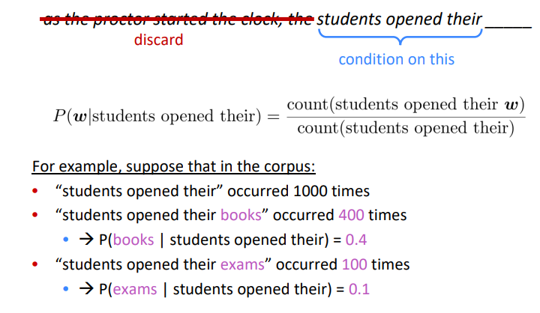

Example of a 4gram language model (aka based on the three previous words).

Problems of ngrams
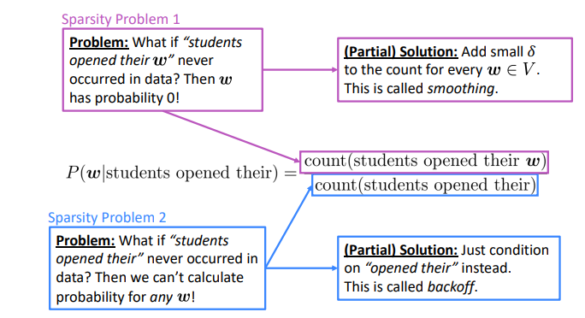

(Note: increasing the n of the ngram makes sparsity problem worse) this is because there are almost infinite possible combinations of words and we also need to store all the probabilities. Typically we can not have n bigger than 5.

(Remember: a language is well-formed over an alphabet if the sum of the conditional probability adds up to 1. Also when we fix a context and we want to predict the probability given all target words that sum needs to be exactly equal to 1)

Another problem of the ngram (in particular of a small ngram) is that we lose the long-distance dependencies. The computer which I had just put into the machine room on the fifth floor crashed. We lose the connection between the subject (the computer) and the verb (crashed). But we often get away with ngram models.

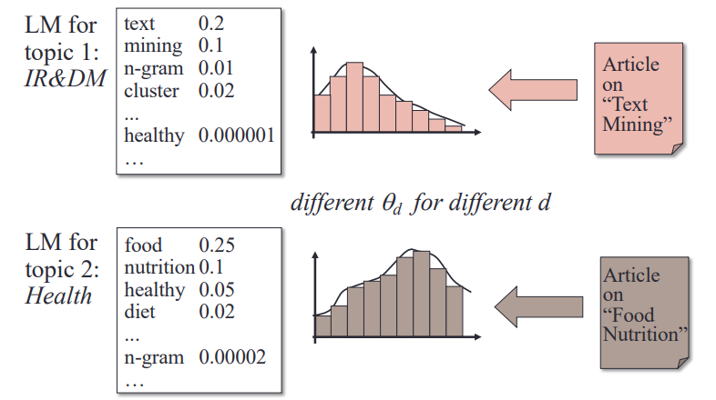
The distribution of the probability when you build the model depends on the corpus where you actually count the frequencies. If you have two topics the distribution of the words will be different. You will have two really different language models. Knowing what you have in your data is important (what you will have as a model will reflect which data the model saw before).

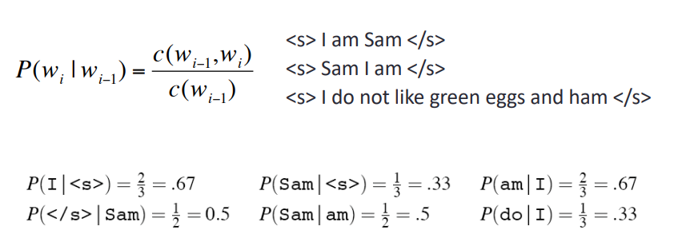
Example of bigram

The probability of a word given a context can be computed just by counting.

[c = count]

Example: I have three sentences
- <s> I am Sam </s>
- <s> Sam I am </s>
- <s> I do not like green eggs and ham </s>

<s> it is a special token that indicates the start of a sentence. While </s> indicates the end of a sentence. In this way the system knows how to stop. For the system <s> and </s> are just like words.

Estimating Probabilities
P(q_{i} | D) = $\frac{f_{qi}, D}{|D|}$

How many times a word appears in a document D divided by the document size (number of words).

Smoothing
(See n-gram language modelling for a clear explanation and example).
A lot of words have 0 probability. We need to assign some sort of probability. Missing words should not have zero probability of occurring.

In the end, to overcome some limitations of statistical language models (such as ngram) we will use neural networks such as RNN recurrent neural network.

Evaluate a model
We need to evaluate a model to check if our language model is good or not. To measure how good it is you need to have a train set and a test set. We find the best parameters of the language model on the training set and then we test the model’s performance on data that it hasn't seen (test set).

(Remember: we can not allow test sentences into the training set)

Extrinsic evaluation of n-gram models
To compare two language models A and B as spelling correctors we check how many misspelt words are correctly classified. Then we compare the accuracy for A and B.

Sometimes to evaluate a model we use perplexity. You count for each sentence the probability of that sentence and you do the inverse of that probability. To calculate the perplexity you use another corpus that was not included in the training data and you compute the probability and compare it with the language model that was built. In the end the model with the lower perplexity is the best one between the two.

Minimising perplexity is the same as maximising the probability.

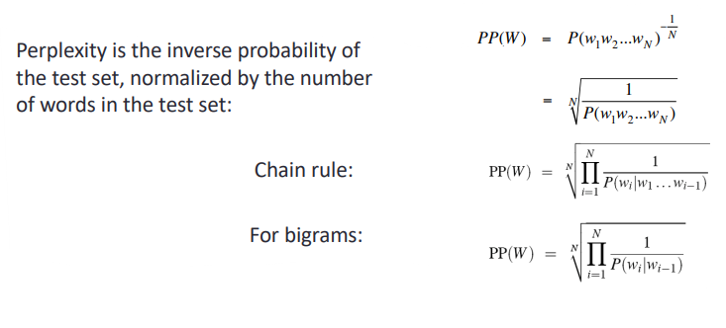
The model with a lower perplexity is the best model. A model is good if it is able to predict words that were never seen (aka words that were not present in the training set and are only present in the test set). If you have a word w_{i} that is only present in the test set you want to maximise the probability of having it after the word w_{i-1} (that is actually the one before w_{i} in the test set). Higher the probability of P(w_{i} | w_{i-1}), lower is the perplexity PP(W) and so better is the model.

An example of perplexity value of different N-gram language models was trained using 38 million words and tested using 1.5 million words. Between unigram, bigram and trigram the last one has a lower perplexity (109).

A language model is a probability distribution over sentences: it’s both able to generate plausible human-written sentences (if it’s a good language model) and to evaluate the goodness of already written sentences. Presented with a well-written document, a good language model should be able to give it a higher probability than a badly written document, i.e. it should not be “perplexed” when presented with a well-written document.

Thus, the perplexity metric in NLP is a way to capture the degree of ‘uncertainty’ a model has in predicting (i.e. assigning probabilities to) text.

Lecture 10

A co-occurrence matrix is constituted by a large number of words. For each word tf-idf and PPMI vectors are:
- Long (vocabulary |V| = 20.000 to 50.000)
- Sparse (most elements are equal to 0)

We want to do a dimensionality reduction of the vectors for words, and the vectors should be
- Short (length 50 to 1000, usually around 300)
- Dense (most elements are non-zero)

Singular Value Decomposition (SVD) 😐 - A method for getting short-dense vectors
Aim: take the original matrix $w × c$ and I represent it as a product of three different matrices.

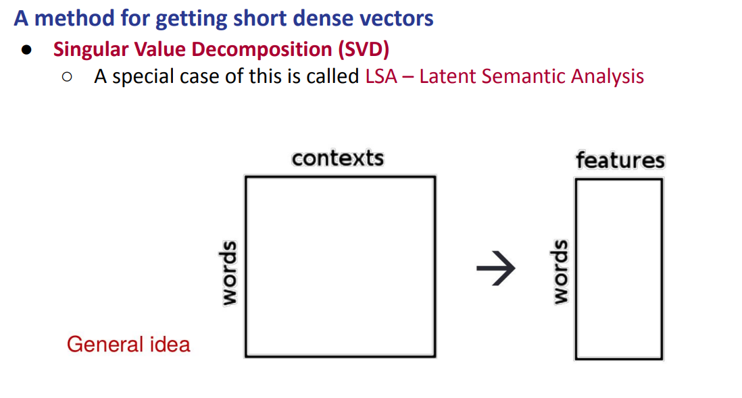

It is the most common technique. We start with a big matrix (words x columns) and we obtain a matrix where the rows (words) remains the same, but the columns are not anymore contexts but features (that are much smaller in dimensionality)

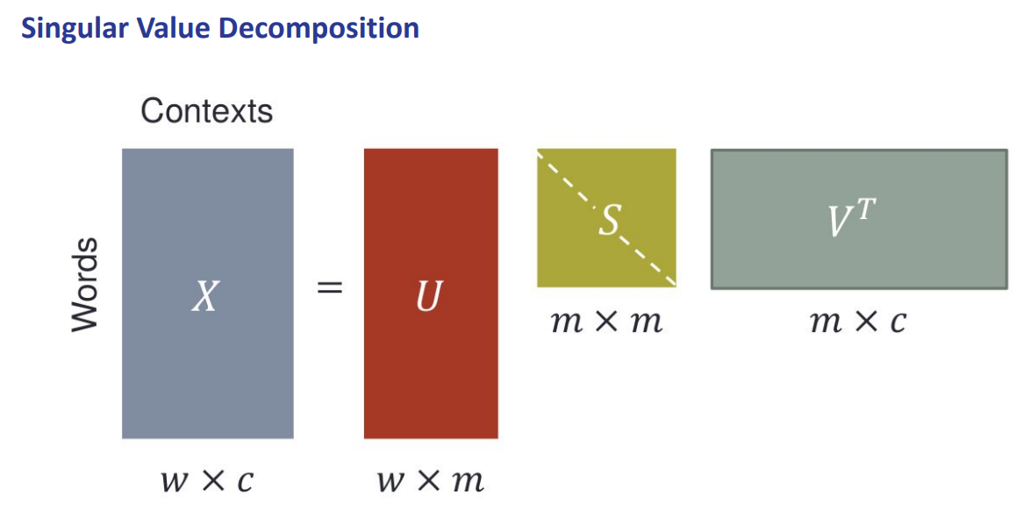
Given any rectangular matrix $w × c$ (words x context) the matrix can be represented as a product of three different matrices that are:
- U: $w × m$. The rows (w) correspond to rows of the original matrix [the $w × c$] and the columns (m) represent the features in a new latent space
- S: $m × m$. It is a square matrix is called singular value matrix and its diagonal express the importance of each dimensions (features)
- V^{T}: $m × c$. Is the transpose of the original matrix, where rows (m) correspond to singular values, while the columns (c) corresponds to the columns of the original matrix

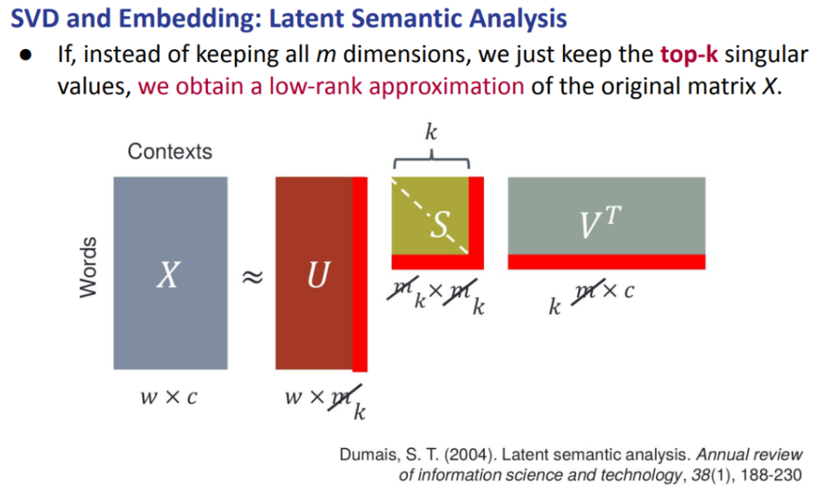
Right now, we just represented the initial matrix $w × c$ as three matrices, we did not change anything: if the initial matrix was long and sparse the three matrices obtained will be still long and sparse.
To compute the reduction,instead of keeping all m dimensions we just keep the top-k singular values, in this way we obtain a low-rank approximation of the original matrix X.

We do not care about all the m, we want to use something like k that is smaller than m. If we take the first k values they will be the most important one given our original matrix.
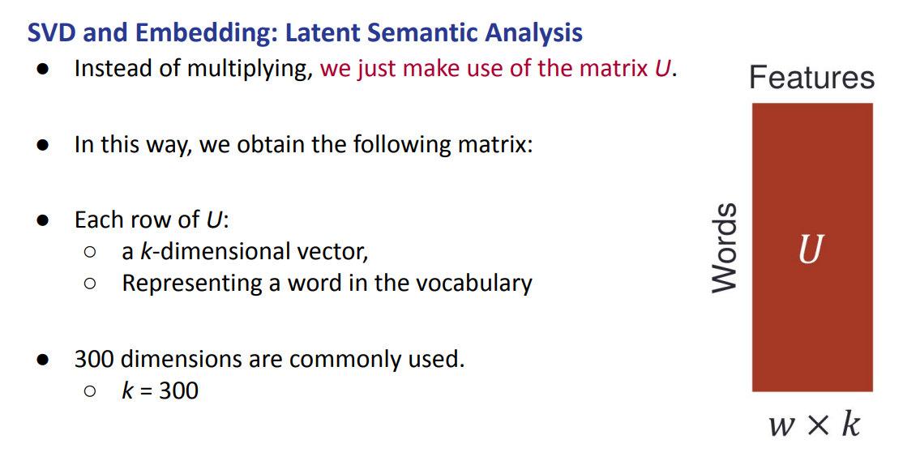

We just use the matrix U: $w × m$ that is the matrix with:
- Rows (w): the word in the vocabulary. We will not lose any word
- Columns (k): usually k=300

- Step 1: build the matrix with the frequencies. It is quite big and sparse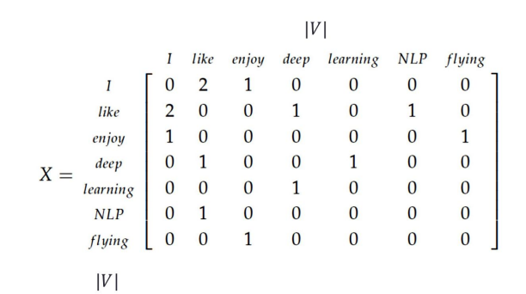
- Step 2: rewrite the initial matrix ( |V| x |V| ) of step 1 as three different matrices
- Step 3: take the first k value that we are interest in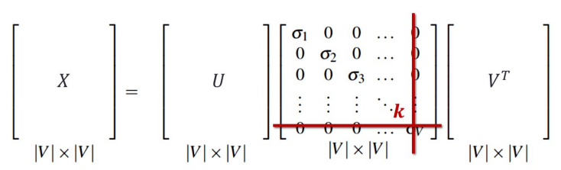
- Step 4: once everything is shrinked we just take the matrix U: $w × m$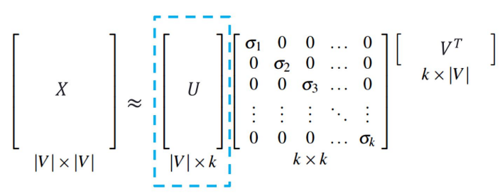
- Step 5: each row corresponds to an embedding for the word.
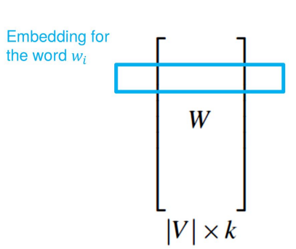

Dense SVD (Singular Value Decomposition) embeddings sometimes work better than sparse PPMI (Positive Pointwise Mutual Information) matrices. But as the first step of SVD you still need to compute and save the big |V| x |V| matrix.

Word2vec 🙂- A method for getting short-dense vectors for word embedding that exploit local level information
Aim: try to avoid the sparse matrix that we need to compute with SVD (Singular Value Decomposition) at the beginning. We want to start directly with a dense matrix. Word2vec builds the word embedding directly without building the sparse matrix before.

Assumption: similar words appear in similar contexts. Also two words that are similar are associated with vectors close in the vector space.

Idea: instead of counting we want to predict, with word2vec we frame a task in a different way. Instead of counting how often each word w occurs near apricot we train a classifier on a binary prediction task: is w likely to show up near apricot?
Also we do not actually care if a word w is likely to show up near apricot. We will take the learned classifier weights as the word embeddings.

We can use a text as a supervised train data for the classifier word2vec. So we do not need hand-label supervision. A word c near apricot acts as gold “correct answer” to the question: is word c likely to show up near the target word?.

- The idea is to treat the target word t and a neighbouring context word c as positive examples
- Randomly sample other words in the lexicon to get negative examples
- Use logistic regression to train a classifier to distinguish those two cases
- Use the learned weights as the embeddings representation of the word

To build a classifier you usually need annotated data (hand-label supervision) but with word2vec is not necessary.

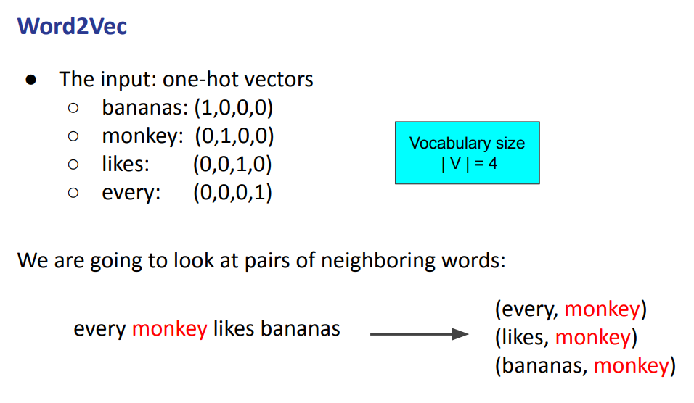
We build pairs of words that we will use as a training set. To build negative samples we can just take random words like fashion

There are two different types of word2vec:
- CBOW: which tries to predict the middle word given the words of the context
- Skip-gram: given the middle word it tries to predict the context word

CBOW (word2vec) (Continuous Bag Of Words)
Goal: predict the middle word given the context. Predicts monkey given every ___ likes bananas
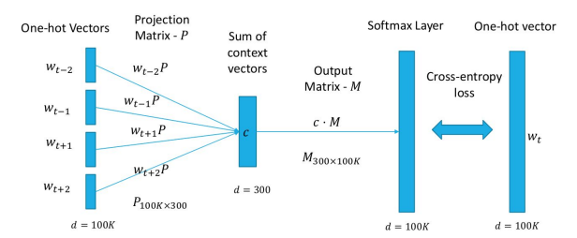

Context w_{t-2}, w_{t-1}, w_{t+1}, w_{t+2} and it predicts w_{t} (the target)

Skip-gram (word2vec)
Goal: given the middle word it predicts the context. Given monkey it predicts every ___ likes bananas.
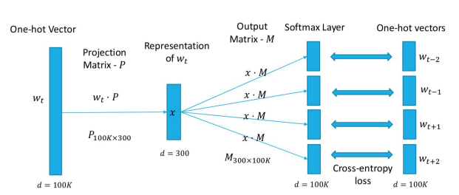

Context w_{t} and it predicts w_{t-2}, w_{t-1}, w_{t+1}, w_{t+2}

Word2Vec Explained - CBOW & Skip-Gram Models
Embeddings:
We have the word chocolate and we want to represent it as a vector. The first idea is to use a one-hot-encoding you will get a vector of size V (that is the size of the vocabulary), and you put 0 at all the places except at the position of the word chocolate where you put a 1. Another idea is to represent chocolate with respect to the property of the object, as an example we could use [edibility, healthy, vehicle] and it would be [0.99, 0.1, 0]. Right now it is hard to understand that we are talking about chocolate, but if we increase the dimension of the vector up to (for example) 100, it might be helpful. We will let the neural network learn the “categories” by itself and so it will come up with its own representation and will use a much larger representation. It will learn by backpropagation.

Each word will have its own vector of representation. In this way if we take the embedding of the word king subtract the embedding of the word man and add the embedding of woman we get a word that is closer to the queen. So it is able to have a sort of understanding of words.

- CBOW (Continuous Bag Of Words): the cat jumped on the table. If we choose a context of 2 and we start from jumped we will have the cat and on the as context. The context words are sended to a model and we try to output w_{t} that is in the middle. The prediction task is useless, is not something that we are interested in. What is important is the representation that it learns from doing this.
- Skip-gram: it is similar to CBOW but instead it takes just the word in the centre as input and it tries to predict the word around it. Jumped is send to the model and it tries to predict the context

Example: skip-gram
We have the sentence … lemon, a tablespoon of apricot jam a pinch … and we have as target word apricot and a context of 2, that is: tablespoon, of, jam, a.

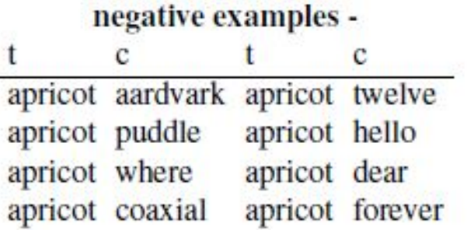
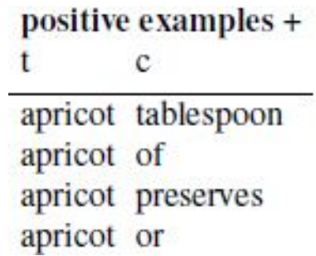
We take some positive and negative instances. We have more negative examples than positive. To create the negative one we simply take random words. Then we train the model.

Word2Vec - Skipgram model in details
Learning Word Embedding | Lil'Log
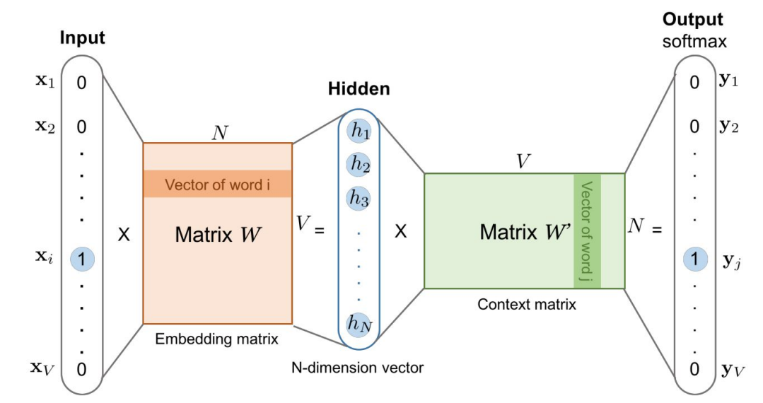

Given the vocabulary size V, we are about to learn word embedding vectors of size
N. The model learns to predict one context word (output) using one target word (input) at a time.

Both the input vector x and the output vector y are one-hot encoded word representations, while the hidden layer is the word embedding of size N. The context matrix W’ is used to predict the target word w_{t} but we actually do not care about that, we just care about the embedding matrix W.

The hidden layer is the word embedding of size N, we will use it as word embedding.

At the beginning of word2vec you need some sort of initial weights. When you are training the model you start with some random values and then during the training the weights will be adapted. We adjunct the word vectors such that:
- They maximise the similarity of the positive target word with respect to the context
- They minimise the similarity of the positive target word with respect to the negative words
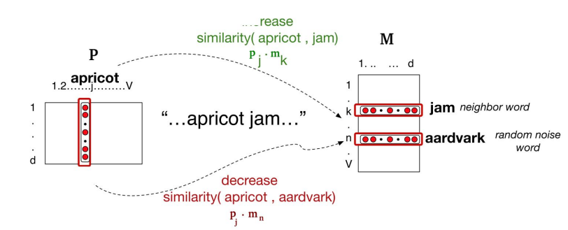
P (projection matrix) is the initial set of embeddings for the target word. While M is the initial set of embeddings for the context word.

In the projection matrix P the target word is apricot and jam is a context word and so we want to increase the similarity between apricot and jam and we want to decrease the similarity between apricot and aardvark.

Word2vec - How to learn word2vec embeddings
There are 6 steps to learn word2vec embedding
- Choose the embedding dimension, ex: d=300
- Start with V random 300-dimensional vectors as initial embeddings
- Take a corpus and take pairs of words that co-occur as positive example
- Construct negative examples
- Train a logistic regression classifier to distinguish positive from negative examples
- Throw away the classifier and keep the embeddings
Then you can do others tasks with the values you learned

Word2Vec - model of CBOW
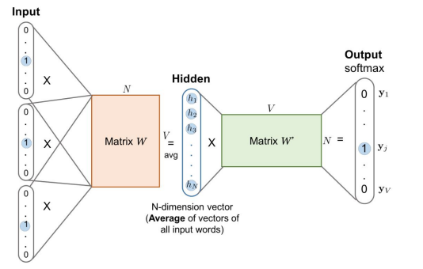

(remember: CBOW takes as input the context that is presented as multiple one-hot vectors and tries to predict a single word (aka the target) that is a one-hot vector).

Word embeddings are a very useful tool
- Can be used as features in classifier
- Capture generalisations across word types
- Can be used to analyse language usage patterns in large corpora

Word embeddings - Embedding learning algorithms
Problems of word2vec
Both flavours of word2vec (skip-gram and CBOW) are missing some global statistics about the corpus. When we build the positive train example we just look at each sentence in isolation, but actually we have the full corpus at the beginning and so we could build some global statistics about all the words and we can incorporate this in the training.

Other limitations of word2vec
- Rare words. Do not have many train examples, not a so good model
- Out Of Vocabulary (OOV) words
- Blends: Obamacare, mockumentary
- Noise due to spelling error. We miss a word just because of one letter
A possible solution is FasText

GloVe 😐- a method for word embedding that exploit global level information
Global Vectors for Word Representations. It exploits global statistical information. It takes advantage of global statistics instead of only local information.

Goal: take advantage of global count statistics instead of only local information.

It learns embedding based on a co-occurrence matrix and trains words vectors so their differences predict co-occurrence ratios.

GloVe: Global Vector - Introduction | Glove Word - Word Co-Occurrence Matrix | NLP | #18
Derive the semantic relationship between words using word-word co-occurrence matrix.
It creates a matrix where it keeps the count of how many times two words are occurring together.

The model leverages statistical information by training only on the non-zero elements in a word-word co-occurrence matrix rather than
- On the entire sparse matrix
- On individual context windows in a large corpus (ex: word2vect)

If we consider two words that exhibit a particular aspect of interest (for example ice and steam) then the relationship of these words can be examined by studying the ratio of their co-occurrence probabilities with various “probe” words

GloVe example
Take three words: i, j, k. Then the ratio of P_{ik}/P_{jk} can be:
- Large: if the word i and k are related more than j and k. As an examples, i = ice, j = steam and k = solid
- Small: if the word i and k are related less than j and k. As an examples, i = cat, j = car and k = automobile
- Close to 1: if the word i and k are related similarly to j and k or if both words are i and k are not related to j in any way. As an example, i = ice, j = steam and k = water or i = ice, j = fashion and k = steam

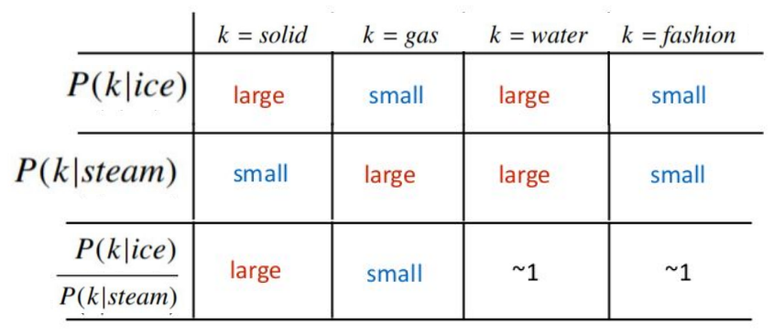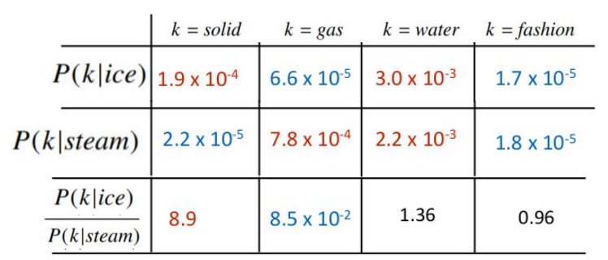

Problems
- Word2vec: exploits local context
- GloVe: exploits global context

Both word2vec and GloVe fail in taking in account that there could be in the corpus other words that did not appear at all in the previous text (OOV words problem). We have to consider a new model that somehow tries to generate word embedding even if that word never appeared before.

The task is to create an embedding that keeps the co-occurrence probabilities inside.

FastText 🙂 - a method for word embedding that exploit character level information
Understanding FastText: An Embedding To Look Forward To | by Aditya Mohanty
One problem of Word2vec and GloVe is that there could be some words that did not appear at all and so have no value, it should be useful to train a model that somehow tries to generate word embedding even if a word did not appear at all before.

We can consider fastText as an extension of word2vec. We take word2vec and we add on top of it another method. Each word is represented as itself plus a bag of constituent n-grams with special boundary symbols “<” and “>” added to each word, they are appended to show the start and end of the token.

With a n-gram = 3 the word “where” would be represented by the character n-grams
<wh, whe, her, ere, re> and <where>.

One advantage is that if a word appears “commonly” in the test dataset but is rare in the training we still have in the training the representation of all its constituent n-grams. So if we miss a word maybe we will not miss all his n-gram and so we can actually construct at least something.

FasText has hyperparameters [minn] and [maxn] that represent the smallest and largest n-gram respectively; they can have the same value.

Also fasText can be quite good. Also for unknown words sometimes it performs good, while sometimes bad.
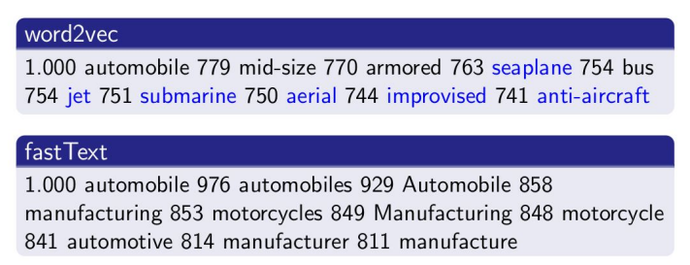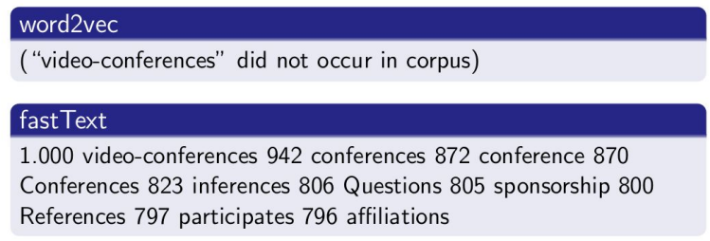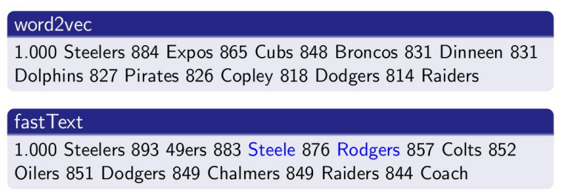
Similarity between the words, given automobile with word2vec the most similar word is automobile itself, while with confidence level 0.779 is mid-size. On the other hand with fastText after automobile itself we have with 0.976 automobiles.

Furthermore with word2vec if the word video-conferences did not appear at all in the training with fasText we are still able to find the similar words.

But sometimes fasText is wrong, see the third example.

Properties of embeddings
The choice of the size of the context window will impact on the quality of the embedding, the rule of thumb is:
- Small context window (±2): something more syntactic similar (the role of the word)
- Long context window (±5): something more semantic similar (meaning of the word)

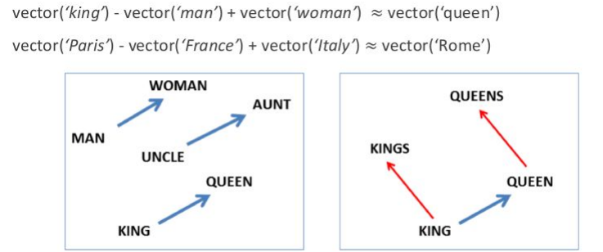
With embedding we can build some analogy patterns. We can “play” with the distance.
For embedding having more data helps, but also we need not only more data but high quality data. Usually training on something that is a little bit smaller (aka smaller corpus) but well written (aka less noise) is better, there is always a tradeoff.

Visualise word embeddings
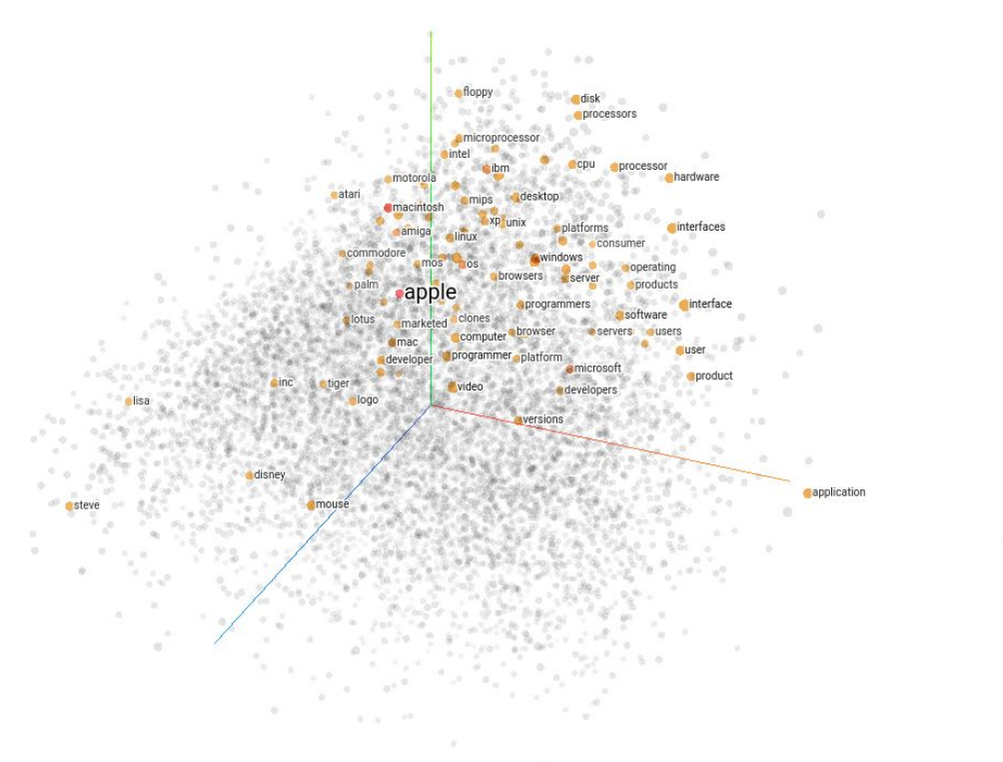

It is possible to visualise word embeddings by using PCA (Principal Component Analysis) Embedding projector, the goal is to take a set of points in a high-dimensional space and find a faithful representation of those points in a lower-dimensional space (typically 2D or 3D)

Evaluate embeddings
Once we have an embedding we can evaluate it. There are two board families of evaluations.

- Intrinsic evaluation: we evaluate the representation without any further trade. You take the representation as it is and you can visualise or check if the similarity across vectors correspond to something that makes sense. It is easy to compute but it does not say much about the embeddings features. Helps in understanding and improving individual components. Use some metrics to do the evaluation.
- Extrinsic evaluation: evaluates the impact of the representation on another task. It is more demanding than intrinsic evaluation and you need to train another model that is used as an initializer for a classifier doing another task. If you generate a word embedding with word2vect, GloVe and FasText then you use all of them to build three different classifiers and you can check which one got the best performance. Focuses on the overall impact of the model. Evaluate how good the model can answer a question or document classification.

While intrinsic evaluation focuses on the components of the model (pos, ner, machine translation), the extrinsic evaluation focuses on the overall performance of the model (sentiment analysis, question answering, document classification)

Embeddings reflect cultural bias
There are cultural biases that are inside the model (because they are in the data), our task is to mitigate them. If we want to build a sentiment classifier to recognise from text if the writer is expressing positive or negative opinions about things we use some typical word embedding (Word2vec, GloVe, FasText) that are trained on massive corpus and classified by a human. But it results biases (and racist).

Lecture 11

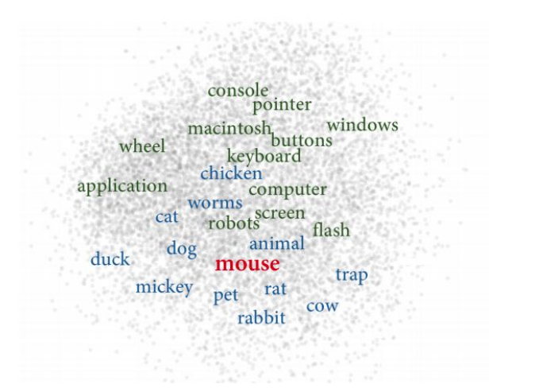
Embedding Learning Algorithms

The problem was that a word like mouse have two different meanings related to two different fields (mouse of a computer and the animal)

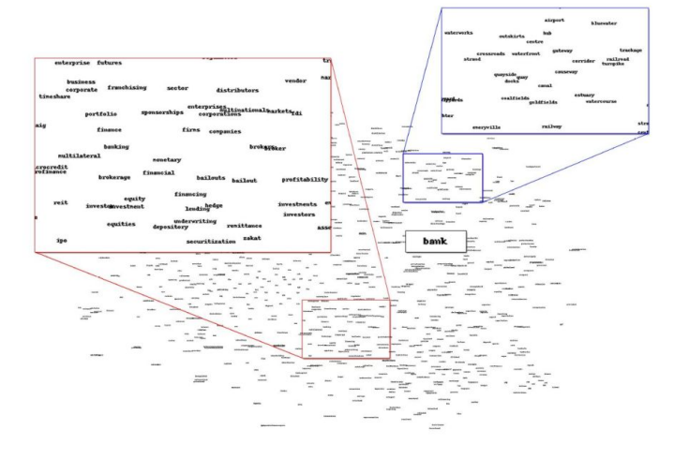
We have a problem of meaning conflation deficiency, so far a word could be seen as a mapping of a single vector but a word can have multiple meanings and so we can not capture polysemy.

The word bank was located between two different senses (bank for money and bank of a river). This is a problem because it is geographically located in the middle, while it should be close to both the two different fields of the word bank. Furthermore if it is in the middle it might even be close to unrelated words of another field.

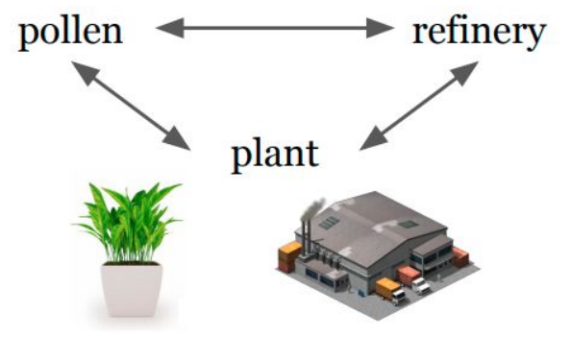 ⟹ 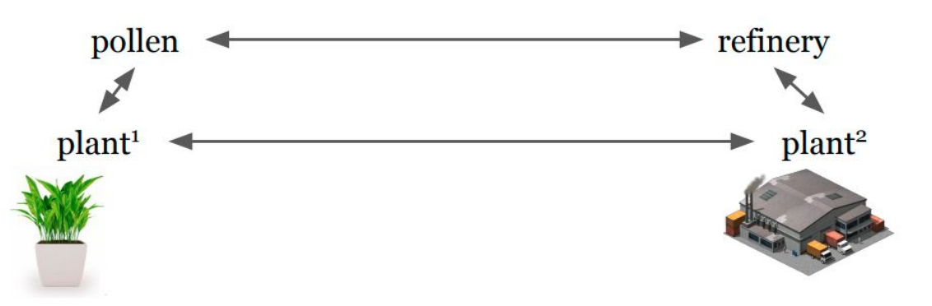

Plan can be an ambiguous word, ideally we would like to have two different representations (plant¹ and plant²) where one is related to the word pollen and another vector representation for the other meaning of plant that is closer to the topic of refinery.

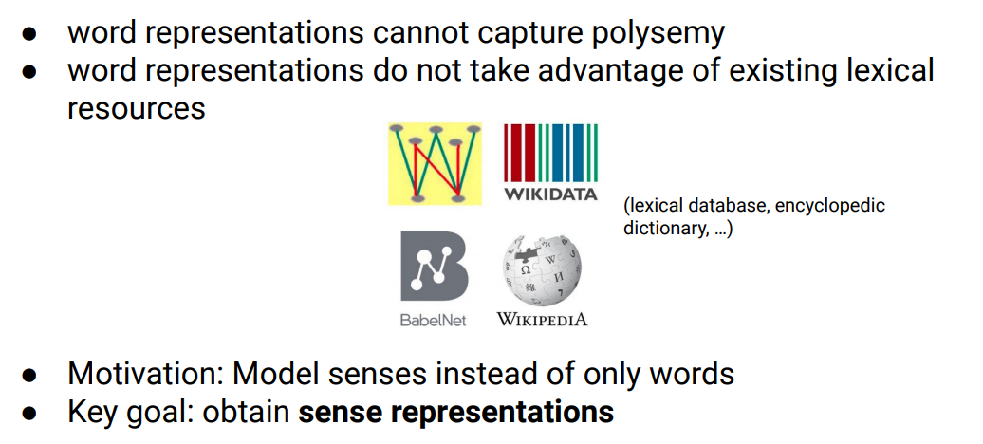
We have some lexical resources that so far we did not exploit and they are a sort of dictionary where for each word the dictionary lists the senses of a word and it gives definition about the senses and examples and provides relations between words.

Sense representations: two branches
Usually in order to obtain word representation we have two branches
- Unsupervised sense embedding 🙁 : it basically learns sense embedding by exploiting text corpora only, try to learn senses from raw corpus. It tries to differentiate for each word different senses. Usually they are not interpretable because they are not really linked to any dictionary, provide different senses but can not understand to which is related. Also they do not exploit any resources.

- Knowledge-based sense embeddings 🙂: they use dictionary (so we do have lexical information) and we can use to learn sense representation and we can see the representation for each sense (because is linked to a dictionary, so it is interpretable)

SensEmbed 🙂 - part of knowledge-based sense embeddings
It leverages an encyclopaedic dictionary and word2vec to build sense embeddings. There are two steps:
- Uses a disambiguation system to disambiguate a corpus. Try to generate for each word a sense from a dictionary
- Uses Word2Vec to actually learn sense embeddings from the sense-annotated corpus

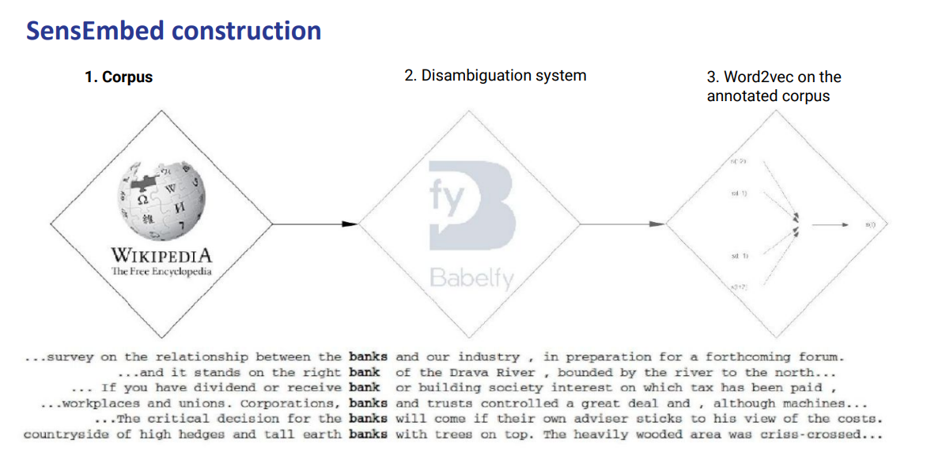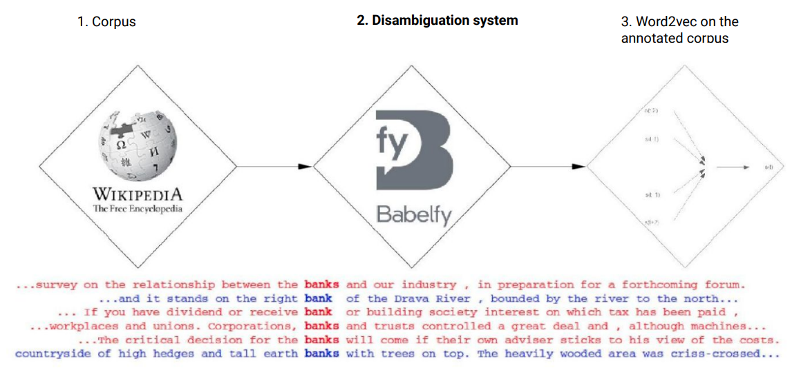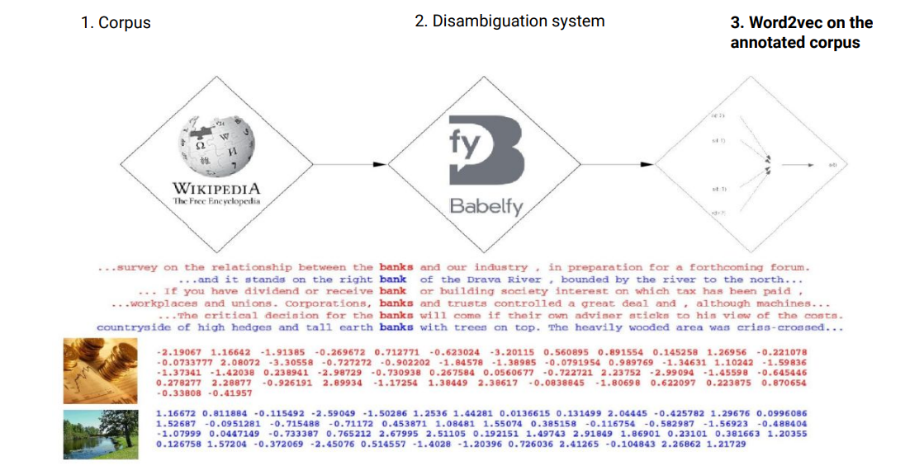

As an example it takes Wikipedia corpus (a bunch of sentences that focus on the word bank)

Then SensEmbedding uses an off-the-shelf system (like Babelfy) that takes a word and links it to a dictionary. Basically you rely on the accuracy of the system but if the system is good enough then the error that the system could do will not impact the representation so much (anyway, better system ⟹ better it is in learning the sense embedding of a word)

Then you learn word2Vec on top of that to create the embedding of the words. When you train word2Vect you have two different representations of the word bank.

SW2V🙂- part of knowledge-based sense embeddings
Sense Word to Vec.

SW2V it is similar to SensEmbed but they differ in the fact that with SW2V in a way you can choose a sense. SW2V also uses its own disambiguation system.

SW2V needs a lexical dictionary to link a word to a particular sense, the dictionary can be seen as a sort of semantic network because it does not provide for each word a list of senses but furthermore provides the relation between all the senses: synonyms, antonyms, semantic and phonological relations between different words.

Idea of SW2V: given as input a corpus and a semantic network it uses the semantic network to shallowly link to each word its associated senses in context. In general, the idea is to use the relations between the senses and then choose the senses that are more connected to other senses.
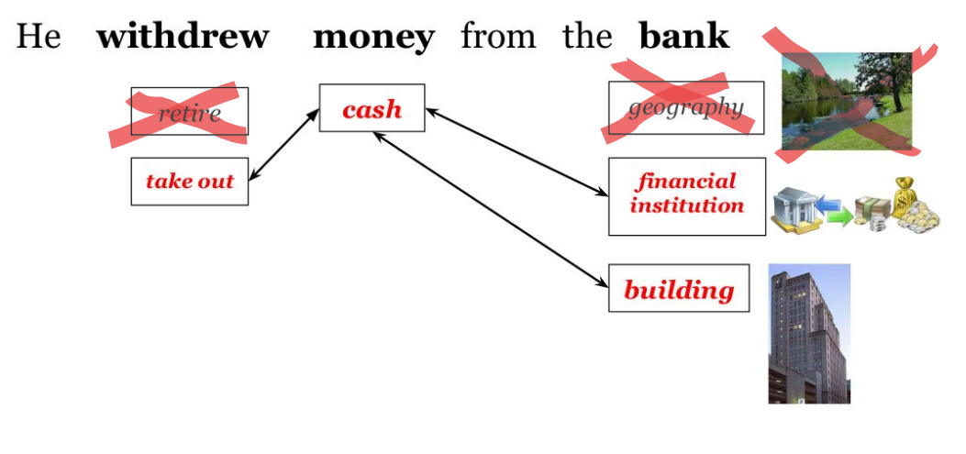
As an example the word withdrew has two possible senses, money can have only one sense and bank has three different senses. Those senses are provided by the lexical dictionary, to be more precise: the dictionary (aka the semantic network) actually provides the relations between the senses. If we look at the relations we can see that the relations connect different senses. We then exploit the connections and, for example, if the word bank is linked to two or more senses we will use both senses (we can imagine that probably there is only a slight difference between the two senses and both of them are fine). Also, in case you have more connections you will need to have a cutoff to see which senses are more connected to others senses and then decide.

SW2V architecture
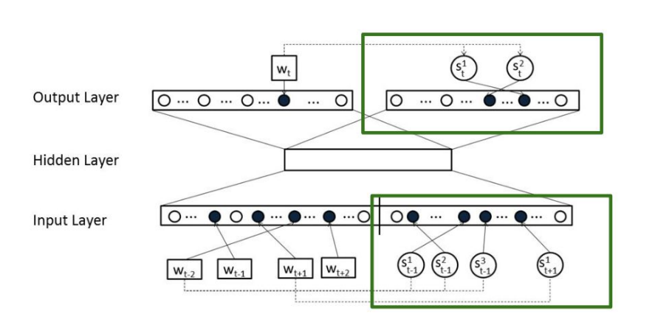
SW2V can be considered an extension of word2vec (to be more precise it is the CBOW version of word2vec because we predict the target word from the context). With SW2V we add the green part, that is the senses that appeared in the input senses (from the example before we would need to add as input the word retire, take out, cash, geography, financial institution, building) and we will get as output the actual senses (take out, cash, financial institution and building).

----

Question: if I independently train word2vec embeddings in an English corpus and then on a Finnish one, can I compute the cosine similarity between English and Finnish words? ⟹ no.

To be more precise you can mathematically compute it, but it has no meaning to do the comparison between the English and Finnish embeddings because they live in two different vector spaces, so there is no meaning in doing this operation of comparison after you trained a system in one language.
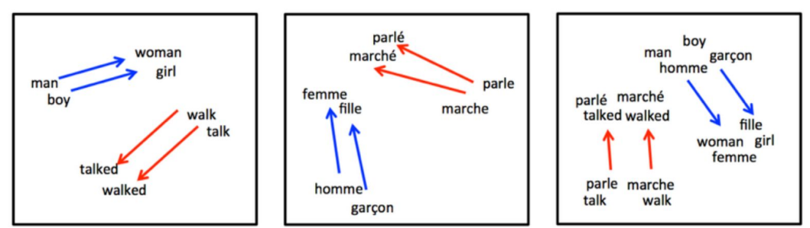
Goal: we want a system that can link the words with the translation close as much as possible to the original word to actually compute the similarity between the two words.

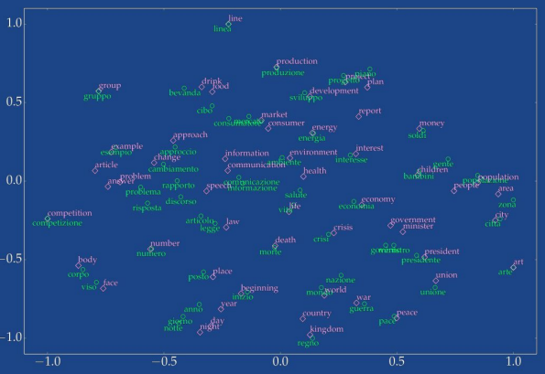

We can see that words with similar meaning across different languages have a similar vector. Regno and kingdom should be considered to be similar (and so they should also have a high cosine similarity), so they should be closer to each other.

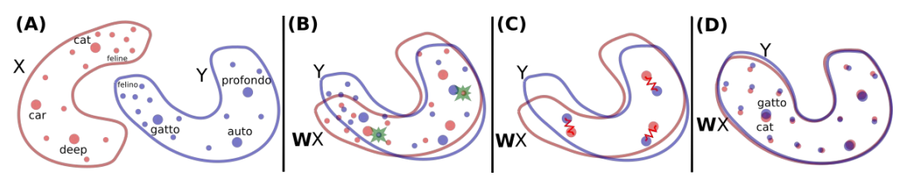
If we have a different vector space we can not compute the cosine similarity across the two vector spaces. If we train one on the English Wikipedia and another on the Italian Wikipedia we will probably get two distributions that are more or less similar. We would like to have a way to compute the similarity and to do so we must “play” with the representation and align the two different distributions. We need to find a matching of the two representations, so you try to find a rotation mapping until gatto and cat are close to each other. To find the rotation mapping you do not need to use all the words, but just use a bunch of them.

The goal is to learn a matrix W that tries to find a matching between the two representations.

---
Context window size
- Large context window: makes topically similar words closer (sport, baseball, referee (arbitro) are grouped). Semantic
- Smaller context window: makes syntactic or functional words closer (batting, running, jumping are grouped). Syntactic

Positional contexts
Should the context features be different for words in different positions? If the word cat happens on the left of word1 and two on the right of word2 should cat be treated similarly or should the word be treated differently by also encoding the position in the context? Positional contexts seem to help if we care about grouping syntactic functions or words with similar parts-of-speech.

We need to decide before the context window size and the positional contexts.

Syntactic window
If I have the sentence John saw a great white shark with his telescope if I use a context window of size one for saw I have as context John and a. On the other hand if I use a syntactic context I will have John and shark that is a way better context than John and a.

We have several choices possible for preprocessing text for word embedding
- Should the words be lemmatized? Should I map good, better, best to the same word good and give, gives, giving and gave should all be mapped to give? We will definitely reduce the complexity, but we will lose some information, there is always a trade off
- Should words retain their capitalization? Apple and apple should be mapped to the same word?
- Should we filter out frequent and rare words? Should we remove words like of and octothorpe?
- Should we filter out long and short sentences?

There are some problems also:
- Antonyms (opposites of a word) tend to be embedded together (cold and warm will be found in the same context, so they will have a similar representation).
- It is unclear how similarity is defined: is cat closer to dog or tiger?
- Embeddings may exhibit gender, racial or ethnic biases
- Word sense is ignored: bank could be a financial institution or a river bank
- There are also obvious things that are not present in the text. Most sheep are white, but black sheep is more frequent than white sheep (we usually don’t specify the colour if a sheep if it is white)

Contextualized word embeddings
Word embedding: set of techniques in NLP where words or phrases from the vocabulary are mapped to vectors of real numbers.
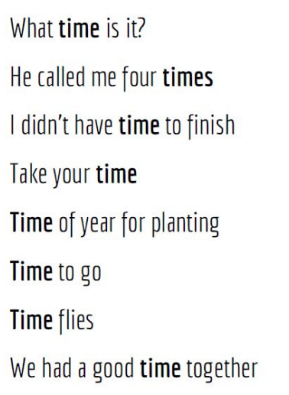
You have a list of sentences that focus on the word time. Time has different meanings and it is located in different positions of the sentence (sometimes it has different meanings but is related to other meanings).

Words are semantically dynamic, they change roles depending on the context in which they appear. We need dynamic word embeddings.

The “new” idea is that words do not appear in isolation, the semantic and syntax meaning depends on its context, furthermore we are able to disambiguate depending on the context, so the context has a fundamental role in disambiguation. And so, why not learn the representation for each word in its context?

The sentence: “Ask not what your country can do for you, ask what you can do for your country”

Have 9 word types, and 17 words tokens
- Word types: are the unique objects in the text, even if ask appears two times in the text we consider it as one (we do not care about the context).
- Word tokens: are instances of the types, it is related to the use of a concept, just count how many words there are in a sentence (we care about the context).

So far the embedding methods for a word were composed on word types. But now we should use word tokens instead because we want to use the context of the word.

Word tokens embedding should:
- Put together (aka unify) words that are syntactically different but are similar in meaning, like bunny and rabbit.
- It should also understand that go and went are similar, but not the same, they are slightly different from each other.
- Separate words that are polysemous (single word with more than one meaning).

Type embeddings maps words to vectors independently from any context of the word, while token embeddings should be functions that construct embeddings for a word on the fly, and there is no fixed “bank” embedding (embedding should come alongside with the context), only the usage of the word decides what the word vector is. The token embedding should take as input a sentence and give as output the embedding of each word, also if the sentence changes the function should give a different embedding (aka it should be dynamic).

N-gram language model part 2
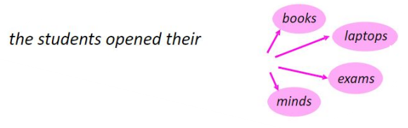
The task of a language modelling is to predict what word comes next. To do so we can use the n-gram language model.

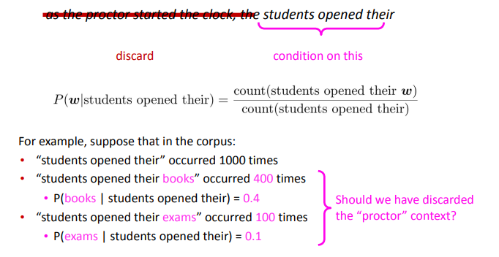
First we make a Markov assumption and so the next word depends only on the preceding n-1 words. Then we apply the definition of conditional probability:

P(A|B) = P(A^B)/P(B)

We also saw that there are some problems with the n-gram language model

On the other hand it is possible to build a simple tri-gram language model over a 1.7 million words corpus in a few seconds with a laptop. Building Language Models

Neural language model
Aim: predict the next word (it is the same aim of any language modelling like ngram) given the context, but one of the main differences is that there should be no fixed “bank” embedding because it should be created on the fly. A neural language model produces context-specific word representation at each position.

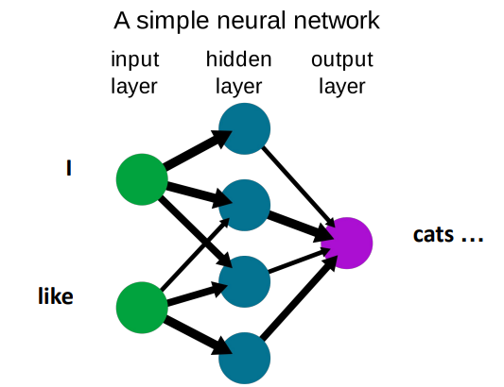

The output of the neural language model is produced thanks to the hidden layer that changes value depending on the input.

How to build a neural language model
We have as input a sequence of words x⁽¹⁾, x⁽²⁾, … x^{(t)} and as output a probability distribution of the next word (t+1) P( x^{(t+1)}| x^{(t)}, … x⁽²⁾, x⁽¹⁾ ).

Fixed-window neural language model 🙁
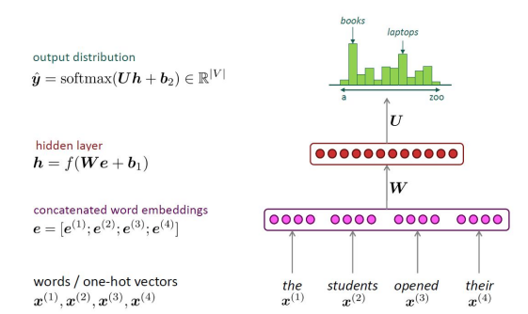
Also similar to an n-gram, that is like a fixed window.

We take as input the words as one-hot vectors and then they go through the concatenated word embedding layer where the vectors of the words of the input are added all together in a single vector that captures the contextual information of the words within the context window and can be used as input for the next layer.

Then after the hidden layer we have thanks to softmax the output distribution of the words in the vocabulary.

- We start by taking the embedding (that we know) of each word. We first concatenate all these embedding vectors together (if we suppose that the embedding is 4-dimensional then the concatenated vector will be 16-dimensional).
- Then we have a hidden layer, it is a linear layer that projects the concatenated vector in a different vector space, but it has some non-linearity along it, the dimensionality will change. Nowadays we have more hidden layers located before the embedding layer and the final softmax.
- Furthermore we take the new vector and we pass it in a softmax activation function, it will give as output a distribution over the vocabulary.

Problem of the fixed-window neural language model
We have the same constraint of the n-gram: we have a fixed window 🙁. But even if you decide to increase the size of the window (ex: from 4 to 10) you may still have a sentence that is 15 words long, so the window can never be large enough. If we have a longer sentence we will remove the entire part that is outside the size of the window that we select (this is the same problem of the n-gram language model).

(Note: it is still better than the n-gram language model, but you still have the problem of the fixed window).

In conclusion: we need a neural architecture that can process any input length.

Recurrent Neural Network (RNN) 😐 - predict the next word
ML with Recurrent Neural Networks (NLP Zero to Hero - Part 4)
In a recurrent neural network the computation proceeds sequentially instead of all at once (as it happens in a fixed window neural language model), it follows the human reading process by going left to right and by also updating the representation of what you’ve read after seeing a new word.

A recurrent neural network starts with the embedding of the words and with an initial hidden state (could be a random vector, usually it has the same embedding size of the words). The hidden state will be the representation of everything we have seen including the new word. At the beginning we have not seen any word yet and so we start with a random vector.

The next thing is to go one word in the future and we see the word the and we update the hidden representation. To compute the update we take the embedding of the new word (e⁽¹⁾) and we multiply it by a square matrix W_{e} we also take the previous hidden state h⁽⁰⁾ and we multiply it to a square matrix W_{h}, then we sum everything and we apply a nonlinear function. After this process we have a new hidden state called h⁽¹⁾ that is not random anymore because we injected with some information of the first word of the sequence. We repeat all the steps.

Finally we apply a soft max layer over h⁽⁴⁾ (because it represents the students open their) to predict the next word.

Note: the W_{h} and W_{e} do not change, we always use the same matrix. Also we could apply this to infinite words.

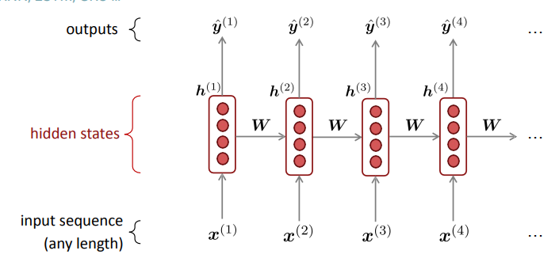
You take the first word and it passes through the hidden state and produces an output. Then when you read the second word it takes into account also the first word. So you have current information and previous information.

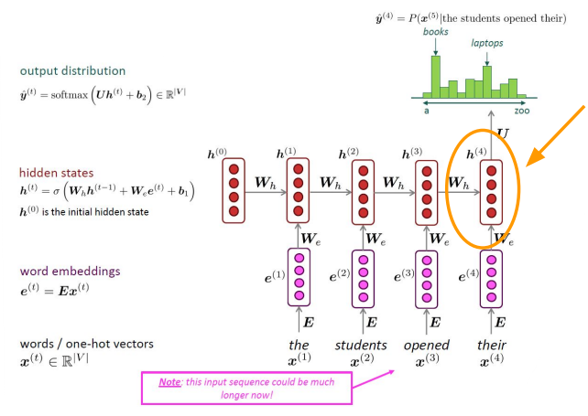
Similarly to the fixed-window neural language model the first layer is the word embedding layer, but instead of the function f(We + b₁) we have a recurrent neural network that started before. So the one in the circle that predicts the final word has incorporated inside the context (the, students, opened) and the current word their.

We have to acknowledge the advantages of RNN
- Can process any length input
- Computation for step t can (in theory) use information from many steps back

But there are some problems…
Problems of the recurrent neural network (RNN)
- It is slow. We have to compute one step at a time: first h⁽¹⁾, then h⁽²⁾ and so on
- It is difficult to access information from many steps back, it is hard for the network to keep track of all the information

ELMo🙂 (Embeddings from Language Models) - part of RNN used to compute the embedding of a word
Two key insights:
- The embedding of a word type should depend on its context, and also the context size should not be fixed because if we fix it there might be a longer sentence, and so the window size can never be large enough. And so we will use a recurrent neural network (RNN) because it can process any sentence of any length.
- Language models are already encoding the contextual meaning of words, so we can use the internal states of a language model (aka: the hidden states) as the word embedding, and it changes every time we give an input (so it is dynamic).

There is always a word embedding layer and furthermore to have a better initialization you can train it before with a static word type embedding (like GloVe, rather than using a random initialization) and then you let the model know how to change it.

ELMO uses two layers of recurrent neural network BiLSTMs (Bidirectional Long-Short Term Memory Long Short-Term Memory (LSTM), Clearly Explained) and to train you use the language model loss, so for each word you train the model to predict what comes next.
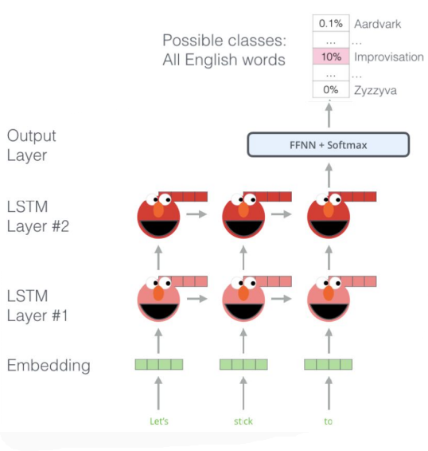

You have the sentence and the word embedding layer (that can be initialised randomly or with GloVe).

After the embedding you have the first and second recurrent layers and the last representation gives you what comes next.

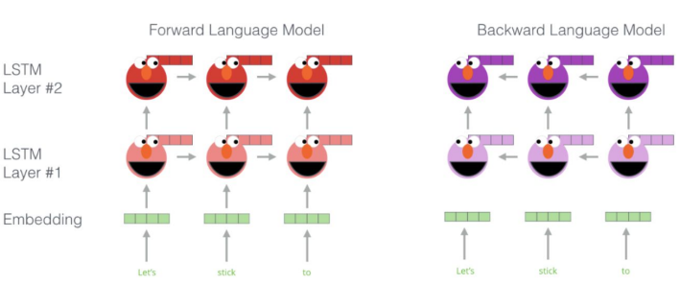

There is a problem of unidirectionality. To overcome this we decide not to read only from left to right, but also read from right to left. We use two models at the same time.

We have two layers because the first layer captures syntactic context, while the second layer captures the semantic context.

Recap: we take the word let’s as a one-hot vector and we apply the initial embedding of that word, it could be a random embedding or a pre-trained one (like gloVe). Then with the first hidden layer and the second hidden layer of ELMo we create a more exact representation of the word. In this way, when we want to predict the word stick we will take into account the embedding of the word let’s.

Elmo used a backward language model, in this way stick will take into account the words before (so let’s) and the following word after stick (like to), In this way we can have a more exact embedding of the word.

With ELMo we have the embedding (could be GloVe or OneHotVector). Our task is to create a new embedding of the target word with respect to the context and not to the word itself.

---

Is a contextual embedder, based on 2 BiLSTM layers and a CNN layer.

Each BiLSTM takes as input the words of the entire sentence containing the target word, they also could be pre-embedded (ex. GloVe, clearly non-contextual).

Once the BiLSTM has processed all the hidden layers, we can concatenate the hidden states (forward and backward) at the step of the target word to get the representation.

We must take into account that we are dealing with multiple BiLSTM layers, that act on different levels of abstraction (to capture both semantic and syntactic), we need to concatenate them.

Finally, the CNN acts on a character level, to handle the OOV problem.

BERT 🙂 (Bidirectional Encoder Representations For Transformers) - Use to predict next word

If I have a sentence: Bicocca University is located in _____, Italy there is one word missing, but as humans we can still be able to fill the blank.

Idea: we can decide to remove some words and let the model fill the gaps and train it. We take a sentence and we hide some words and let the model predict which word to use to fill the blank.

Remember: we should have a compromise between little masking (too expensive to train, there is too much output left visible) and too much masking (where there is not enough context).

We should take 15% of the words in a sentence and try to predict them, furthermore:
- 80% (of 15%) of words should be replaced with [MASK] (aka: blank)
  - I want to [MASK] a book. The model objective is to predict the masked word (buy) based on the context provided.
- 10% (of 15%) of words we replace it random token (aka random word)
  - I want to pizza a book. In this way we improve the model ability to handle the variability of the language.
- 10% (of 15%) of words we leave the word unchanged (but we still let the model predict it).
  - I want to buy a book. In this case the model received the unchanged phrase and learned to understand its meaning and context in the sentence. In this way the model is able to capture the semantic of the word buy and its relation with the surrounding words. BERT does not know if buy is a positive or negative example.

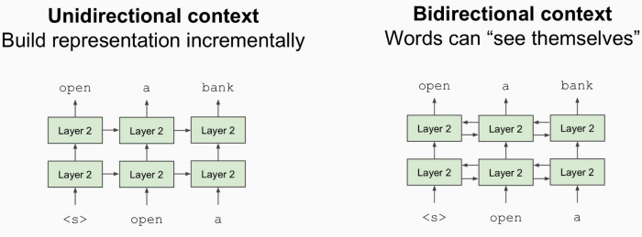

BERT is bidirectional and so the words can see themselves and so not only the words before.

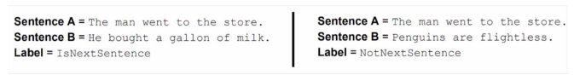
Also BERT is not used only to fill the gaps, but also to learn the relationship between different sentences and to understand if sentence B can be a valid possible sentence after sentence A.

Lecture 12

OOV (Out-Of-Vocabulary) words, a problem of Neural Language Model
Lezione non registrata
Neural language models (such as fixed-window, ELMo and BERT) have a problem related to the OOV (Out-Of-Vocabulary) words, this is because the networks have a fixed vocabulary and also we have a poor representation for not-common and rare words, in the end we have a high risk that something really specific could not be present in the vocabulary.

Open vocabulary to fix the OOV problem
A possible solution is to use a open vocabulary with no fixed vocabulary, but it has some problems: first of all we increase the network size to accommodate a larger vocabulary, and so we increase the complexity and the memory usage, furthermore we decrease also the speed since it would take longer time to train a larger vocabulary. Also another problem is that there are open word classes like names and numbers and so new names and numbers can emerge over time.

Back-off model 🙁 to fix the open vocabulary problem
A possible solution to this problem of open vocabulary is just to replace rare words with UNK, in this way we simplify the vocabulary and we make it more manageable. This method is called back-off models. In the end, when the system produces a UNK word we make a guess at what word it might stands for

But there are some problems of this back-off model, such that:
- Compounds: back-off models face some difficulties in modelling one-to-many relationships found in compounds. We have many rare words that are represented as UNK and so when we need to substitute UNK with a word we have to make a guess
- Morphology: it is hard to predict the inflection, the model might generate an incorrect form of the word.
- Names: there are multiple languages that use different alphabets, the back-off model might translate a Chinese name with UNK token, in this way we have an inaccurate representation or transliteration of the names. Also not all the words (like the names) can be found in a dictionary

Wishlist as another possible solution to the open vocabulary problem
We would like to have as a solution a wishlist that is able to:
- encode all words through a small dictionary.
- Encode generalises to unseen words
- Small text size: usually when tokenizing we split things such as commas to add more tokens. We try to avoid this increase of tokens

BPE 🙂 (Byte Pair Encoding) - for word segmentation
1 5 Byte Pair Encoding
Byte Pair Encoding Tokenization
Another possible solution for the OOV (Out-Of-Vocabulary) problem is to use wishlist.

Idea: instead of breaking words at every white space we will use the data to tell us how to tokenize. We use “smaller pieces” of words (aka tokens) because tokens can be parts of words as well as whole words.

The Byte Pair Encoding (BPE) is divided in two parts:
- Byte Pair Encoding (BPE) starts with a token learner which takes a raw training corpus and induces a vocabulary (a set of tokens) that is the vocabulary that the tokenizer will try to map things into.
- After the token learner we have the token segmenter which takes a test sentence (never seen before) and it tokenizes it according to that vocabulary.

The first step is to start with a vocabulary containing all the characters (A,B,C, …, a,b,c,...) present in the dictionary. After this we take the two characters that are most frequently adjacent in the training corpus (ex: A and B) and we add the merged symbol AB to the vocabulary. In the end we will replace every adjacent A and B in the corpus with AB until k merges have been done.

----
From notes

The first step of Byte Pair Encoding (BPE) is to create a vocabulary with all characters in the dictionary (in this case we mean the words with their frequency), then the next step is to add pairs of characters that appear together a lot (as an example we could add together the bigram es), and we keep repeating this (like we could add together the trigram est).

In the end we have a hyperparameter that controls the vocabulary size. When you reach a certain vocabulary size you stop adding new ngrams.

Encode a new word:
You begin the encoding of a new word by splitting the word into all its letters.
Then you check what letters you can join (for what sequences letters you
already have said sequence of letters in your vocabulary). You continue
joining until you cannot join any longer. The idea is that way, the input creates
fewer separate tokens (see wishlist)

To encode a new word instead you first split it into single letters (hello ⟹ [h, e, l, l, o]) then

Byte Pair Encoding (BPE) is widely used today, some examples are google, chatGPT

Sequence generation - generate text
We first assume to have an input of a sequence of tokens (x₁, …, x_{T}) € V^{T} and the output is a target sequence of tokens (y₁, …, y_{T’}) € V^{’T’}

Goal: estimate the probability of some possible output sequence given the input sequence. P_{θ}= (y₁, …, y_{T’} | x₁, …, x_{T}) and we frame this as a classification task.

--?
Given a sequence in one language, with machine translation, we translate it in another language. To evaluate the machine translation we check if one translation is as good as the human made one. The blue score is a strategy of evaluation based on n-gram, it evaluates how much the n-gram in the prediction appears in the “gold/official/human” translation. The blue score can be
- 1: the prediction is the same as the gold translation
- 0: no n-gram in common

---?
Summarization: of a source text in a shorter one can be challenging, and a standard metric is the rouge score, it measures how much the word (and/or n-grams) in the human reference summary appeared in the machine generated summaries.

To design a neural architecture to do this we use:
- Softmax activation function
- Cross entropy as loss

Boh non c’è il video porcodddd

Lecture 13

Recap:
- Seq2seq (sequence-to-sequence) is a conditional language model. This is because its preconditions are also conditioned on the source sentence x (aka conditional) and it predicts the next word (aka language model).

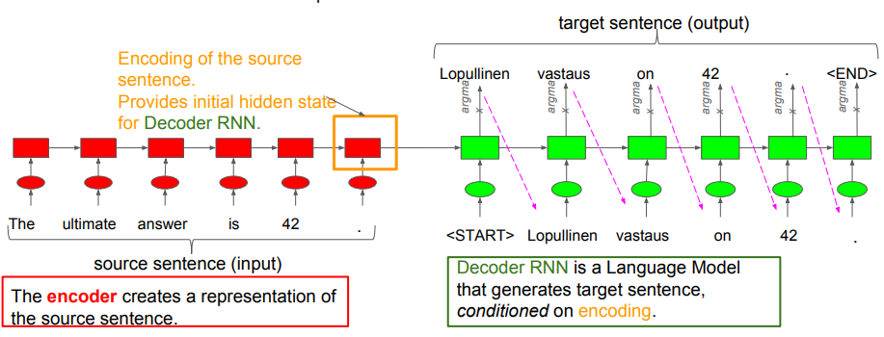
A problem of seq2seq on a translation (from one language to another) task is that when we do the translation we rely only on a summary of the entire sentence (the last hidden state of the encoder) and we compute the translation only thanks to that summary. This problem is also called information bottleneck. Furthermore, if we increase the length of our sentence the performance of translation decreases.

Sequence to sequence with attention 🙂 - for translation
Instead of having a final vector encoding everything of the sentence we will use all the vectors computed before. You want to allow the model to look at multiple timesteps before and not just the final timestep to make the translation. We want to assign a score to all the vectors and a higher score means that we should put a higher attention toward that token. Attention scores are judging the importance of each of the hidden states we computed in the past before making the translation.

We use the dot product between the query vector (in green) and the key vector (in red), we will get four dot product numbers. After this we apply a softmax function to get a probability distribution over all the keys. We will then compute a weighted average of all the key vectors using the probabilities we computed as the weights (it is a scalar that multiplies a vector). Then we sum everything and we obtain a single vector that is the attention weighted average of my keys, it is called attention output. We then concatenate the attention vector output with the query vector (we get a single vector that has twice the size), then a softmax function will take the concatenated vector as input to predict the translation.

To overcome this problem of information bottleneck we use attention. The main idea of attention when we produce the translation we look back to the entire sentence and we focus on some specific part.

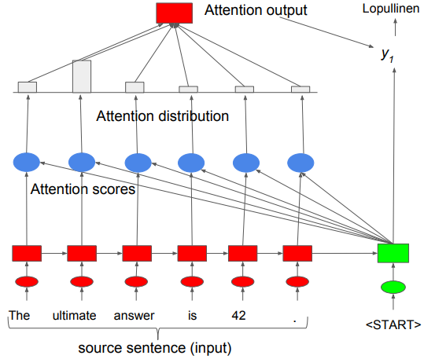
As before, we take as input the source sentence but then we take the representation and we compute a dot product between all the other representations, this is called attention score and we do it for all the words. After getting the result of the dot product we run a softmax activation function to get a probability distribution and it reflects how much we should focus on each word for the translation. Finally the probability distribution is used as a weighted sum of the encoder hidden states, it shows which word carries more information. The final representation is called the attention output and it is concatenated to the decoder hidden state.

We repeat this for each word that we need the translation.
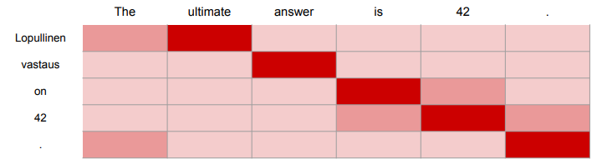
The idea of attention is that we consider the entire sentence but we “put the attention” only on the part of the sentence that in a specific moment is needed for the translation. The sequence-to-sequence with attention seq2seq has great improvement, furthermore it solves the bottleneck problem (because it allows the decoder to look directly at the source, and not just at the summary). It also provides some interpretability, with a heatmap (in the image) we can see where the network is looking when it is translating a word.

To recap: sequence-to-sequence with attention has three steps:
- Attention score
- Attention distribution

- Attention output
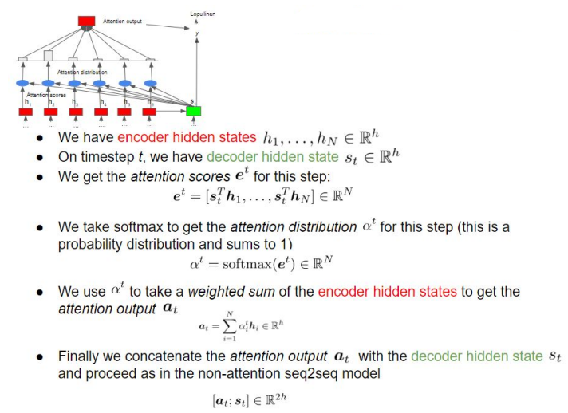

Furthermore, attention is a general deep learning technique, as an example it is used to produce descriptions of images.

- Attention solves the bottleneck problem, it allows the decoder to look directly at the source and to bypass the bottleneck
- Attention can provides some interpretability (like with an heat map)

More general definition of attention
Attention is a technique that, given a set of vector values and a vector query, it computes a weighted sum of the values, dependent on the query. Also we can say that attention is a way to obtain a representation of an arbitrary set of representations (the values), dependent on some other representation (the query).

There are several variants on how to compute attention, but we will focus on only one. But attention always involves three steps:
Given some values h₁, … h_{N} € ℝ^{d1} and a query s € ℝ^{d2} we do in order:
- Computing the attention score e € ℝ^{N}
- Taking the softmax to get the attention distribution α α = softmax(e) € ℝ^{N}
- Using attention distribution to take weighted sum of values to obtain the attention output a a = $\sum_{i=i}^{N}{}$α_{i}h_{i} € ℝ^{d1}

(In particular there are multiple ways to compute the attention score e, step 2 and step 3 stay the same).
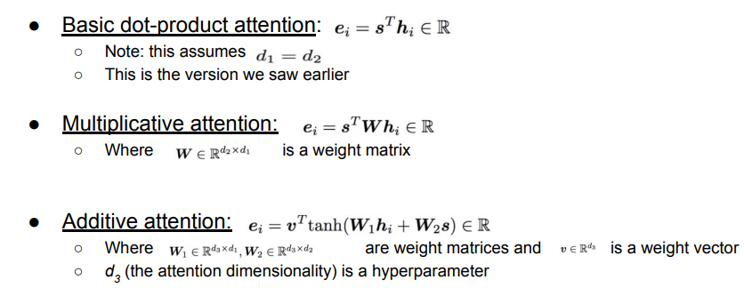
To compute the attention score there are different ways, each of them has some pros and cons (there is always a tradeoff).

The first method (basic dot-product attention) is based on the product on the decoder hidden state and the encoder hidden state, while with the multiplicative attention we also add a weight matrix (that is learned) and in the last one (additive attention) we use two weight matrix. All three have the same goal and the most used is the basic dot-product attention because it is the fastest one.

Transformers
Transformers are a family of models used commonly by chatGPT and many more.

Goal: learn representations of variable length data (because sentences can be of variable length)

A problem of LSTM (Long Short Term Memory) is that it is very slow, even if we have the entire sentences the LSTM needs to read one word at the time. Ideally, to speed up the process, we could design another model that read the words in parallel at the same time.

Attention was a fundamental powerup for the seq2seq, so why not use it for representation? One idea is to use self-attention (to get rid of the problems of RNN). The main idea of self-attention is to take an input sentence to attend to itself.
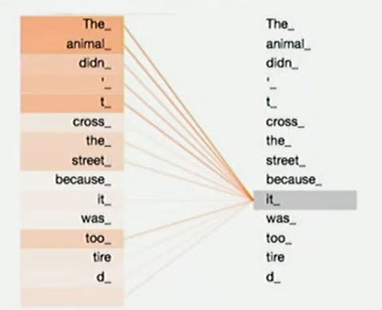
In seq2seq attention was used to move from the encoder to the decoder, while self-attention stays in the encoder, we can consider it as the encoder looking to itself.

An example of self-attention is given by the sentence the animal didn’t cross the street because it was too tired. To build the representation of it we need to focus on just some specific part of the sentence. So the idea is to use the heat map (same as the attention score, but the sentence is the same twice, and not in two different languages). From this we can understand what it is referring to. So, self-attention allows us to look at other positions of the input sequence for clues that can help to lead to a better encoding for the word itself.

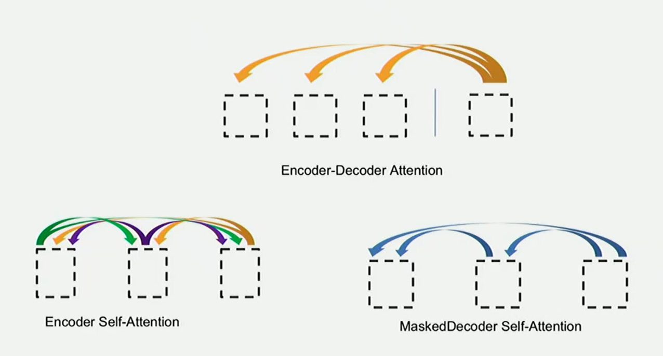
We need to design three kinds of attention:
- Encoder self attention: for the decoder itself: the input look at itself
- Encoder-decoder attention: the decoder is looking at the encoder
- Masked decoder self attention: each word look at the past, because we are generating the future, so we can only look at the past

Self-attention in detail

Step 1 - calculate vectors
The first step in calculating self-attention is to create three vectors from each of the encoder’s input vectors. For each word we create:
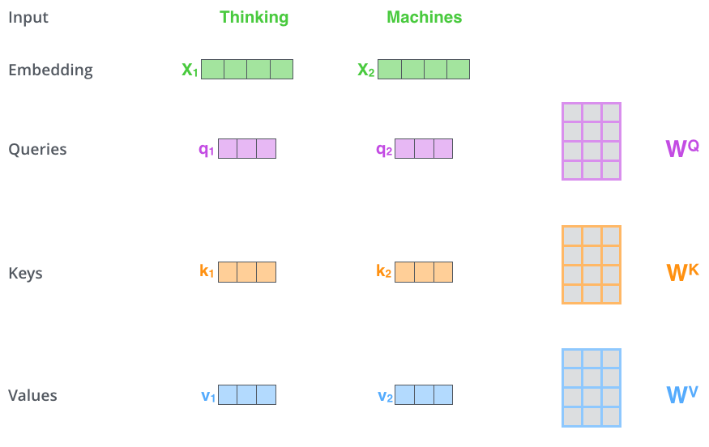
- A query vector
- A key vector
- A value vector
Those three vectors have the same size and are obtained by multiplying the embedding by multiplying the embedding of a word by three matrices that we trained during the training process.

Note: the three vectors we obtain have a smaller dimension (64) than the embedding vector.

Step 2 - calculate the score
The score is useful to determine how much focus to place on other parts of the input sentence as we encode a word at a certain position. If we are computing the self-attention for the word Thinking, we need to score each word of the input sentence against this word.
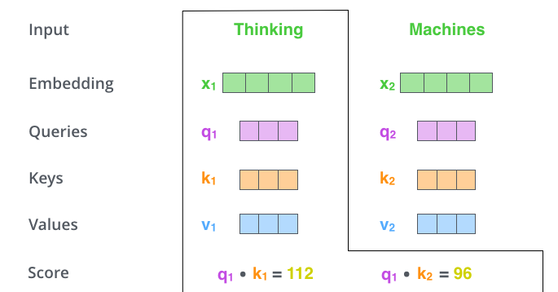
To compute the score we make the dot product of the query vector with the key vector of the word that we’re scoring.
We compute a score for each word, the query vector does not change, while we move the key vector.

Step 3 & 4 - divide the score and softmax
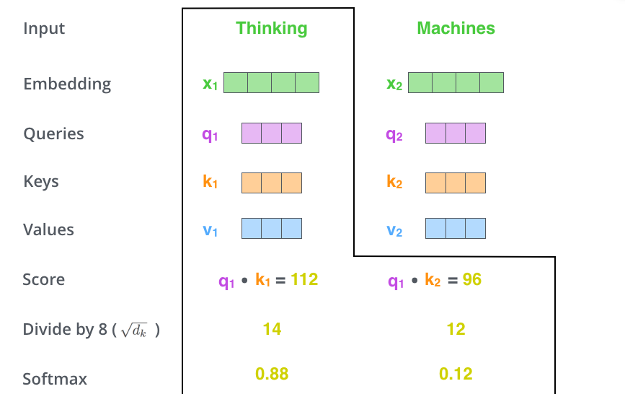
We take the scores just computed and we divide them by the square root of the dimensions of the key vectors √64 = 8. After this we pass the result in a softmax operation to normalise the score.

The softmax determines how much each word will be expressed at this position.

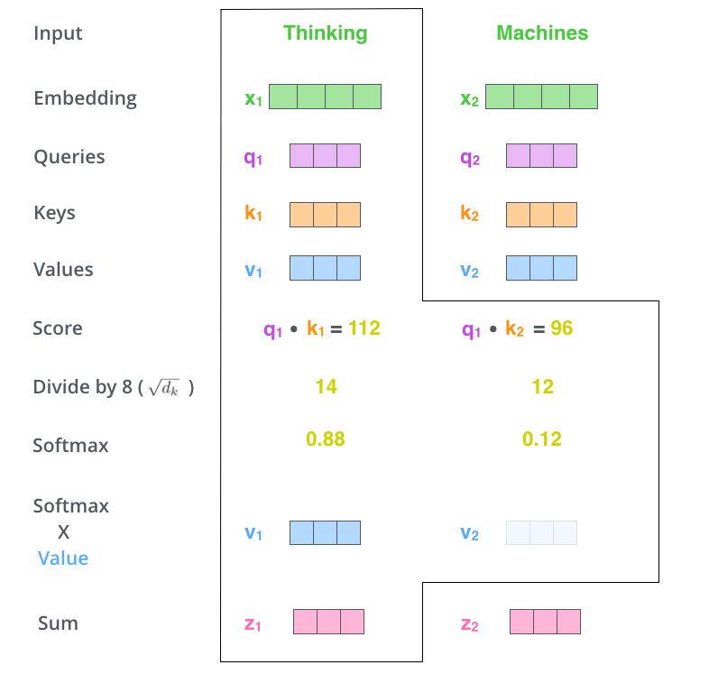
Step 5 & 6 - multiplication of the softmax and sum of the weighted value vectors
Then we multiply each value vector by the respective softmax score, it is a scalar-vector multiplication. We do this to keep intact the values of the word(s) and drown-out irrelevant words (by multiplying them with tiny numbers).

After this we sum up the weighted value vectors.

The resulting vector is one that we can send along to the feed-forward neural network.

Note: all those steps of self-attention are done in matrix form for faster processing, such as:

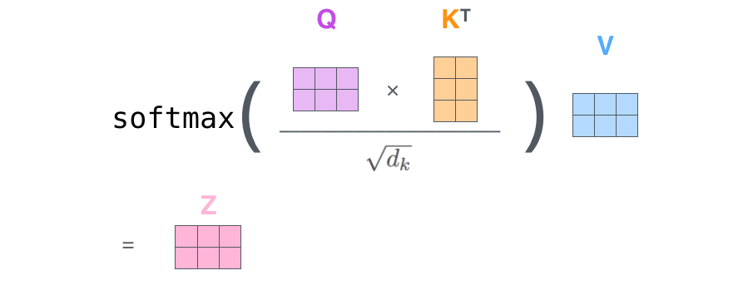
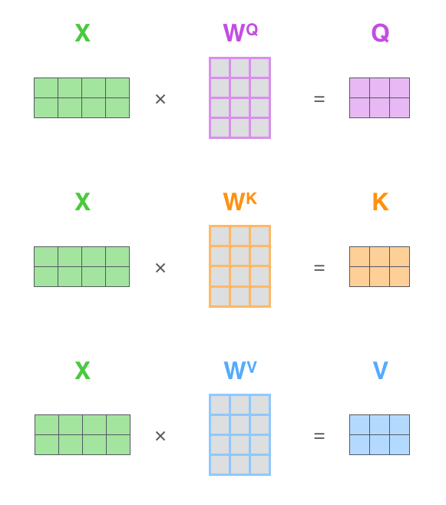

Multi-headed attention: the beast with many heads
Multi-headed attention improves the performance of attention layers in two ways:
- Expands the model’s ability to focus on different positions. Even if z₁ contains a little bit of every encoding it could be dominated by the actual word itself
- It gives the attention layer multiple “representation subspace”. With multi-head attention we have multiple sets of query, key, value weight matrices. Each of these sets is randomly initialised, and after training each set is used to project the input embeddings into a different representation subspace.

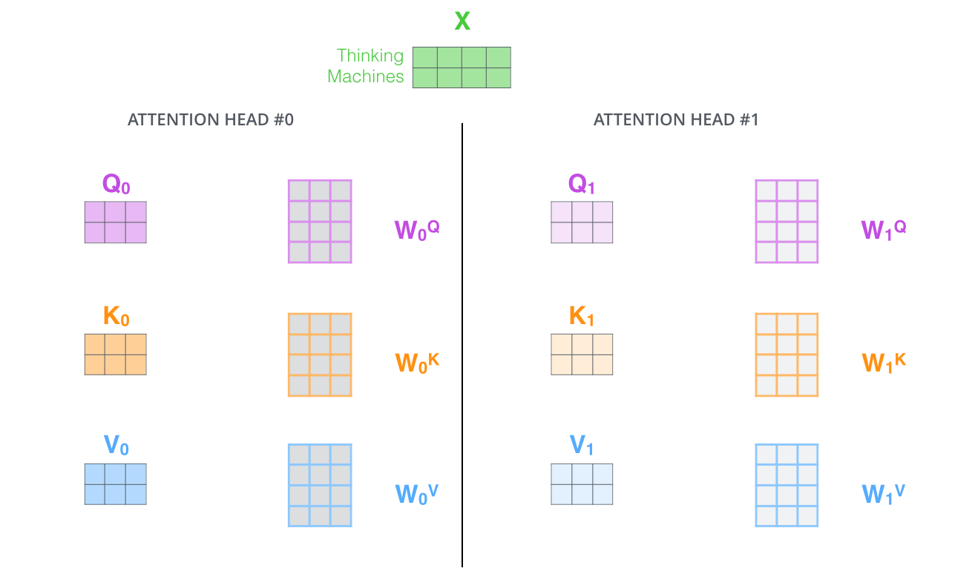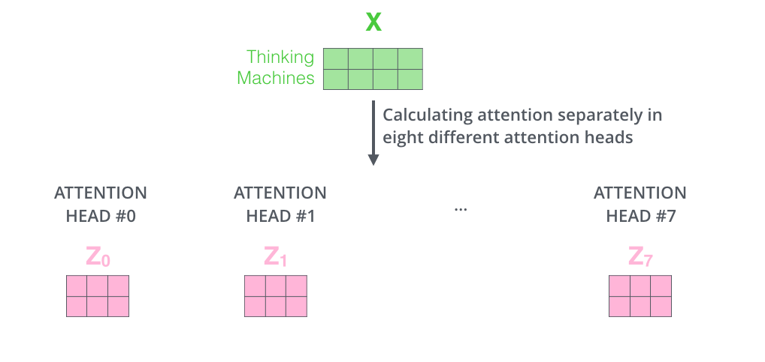

If we do the calculation of the self-attention computed before by using eight different matrices W₀Q, W₀K and W₀V we will get eight different Z matrices. But since we need a singular matrix as output we concatenates the matrix from Z₀ to Z₇and we multiply by a weight matrix W⁰ to obtain a single matrix

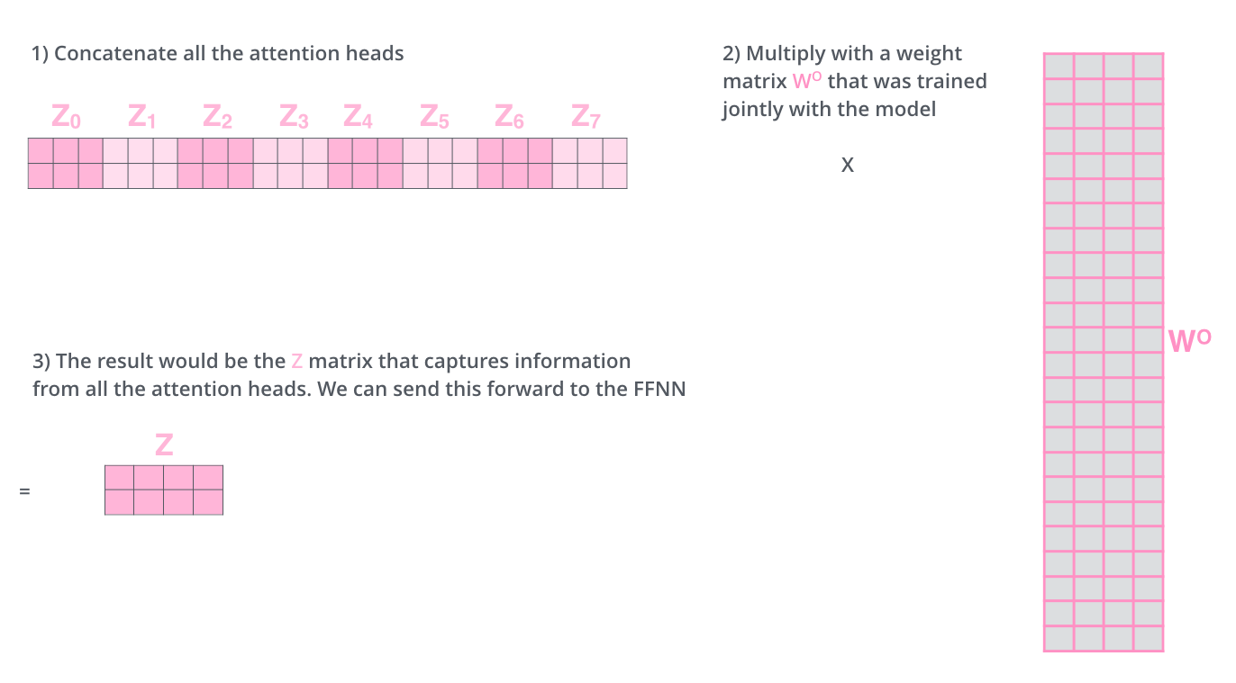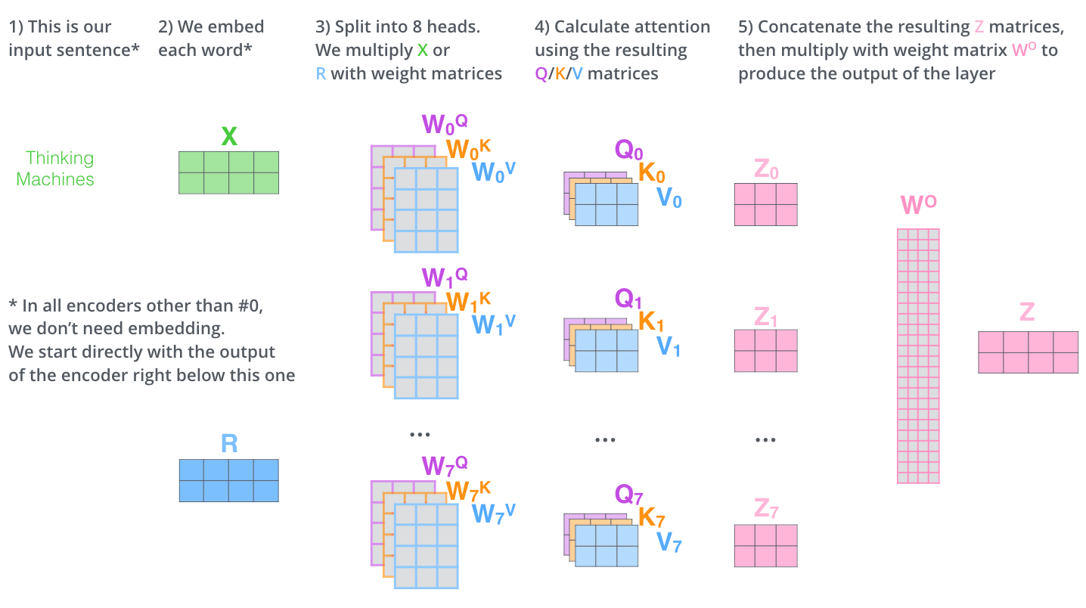
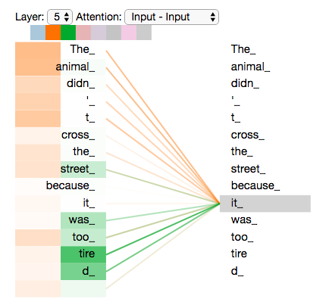

If we have different attention heads when we encode the word it we could have something like this. Also, if we plot all the attention heads to the picture things can be hardened to interpret.

Representing the order of the sequence using positional encoding
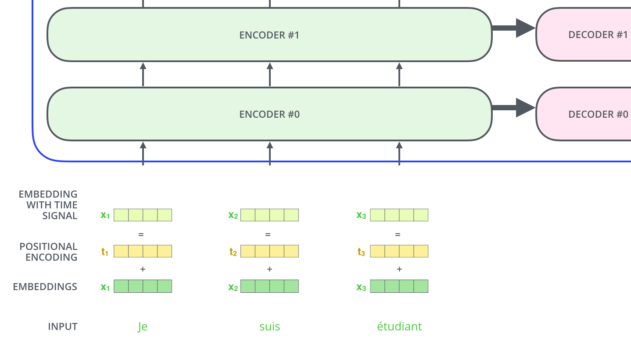
How can we take into account the order of the words in the input sequence? To do so the transformer adds a vector to each input embedding, this vector follows a specific pattern that the model learns, which helps it determine the position of each word or the distance between different words in the sequence.

The idea is that adding these values to the embeddings provides meaningful distances between the embedding vectors once they're projected into Q/K/V vectors and during dot-product attention.

To encode the positions we use the function sine and cosine, but there are are some important requirements to follow:
- Any position should have the same identifier irrespectively from the sentence length and the words of the sentence. Even if the sequence might change, the positional embedding stays the same.
- The value of the position vectors are summed to the embedding of the word, and since we don’t want to push too far away the embedding from the original position, then the values inside the position vector should not be too large. That’s why we use sin and cosine: because they are bounded in [-1:+1]

Sine and cosine are periodic functions and they repeat each other (we don’t use the sigmoid because with sine and cosine we have higher variability also for big numbers), so we would have the same outcome for different positions. To overcome this we increase the wavelength (aka decrease the frequency) so that even for our biggest length the value will not repeat.

For each element of the embedding vector we use either a sin and a cosine and different frequencies (decrease the frequencies). We will give enough information to the transformer to understand exactly the order of the words in the sentence.

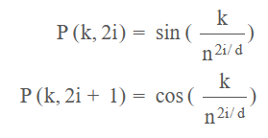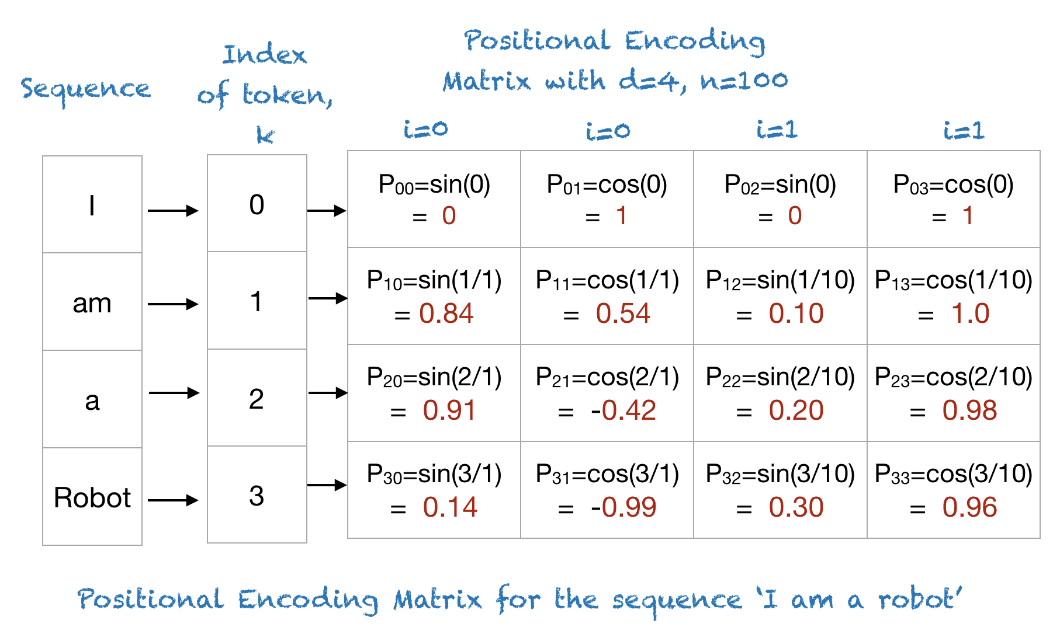

Lecture 17

Machine translation

Purposes of machine translation
- Assimilation: reader initiates translation, wants to know content
- Communication: participants don’t speak the same language, rely on translation
- Dissemination: publisher wants to make content available in other languages (requires high quality, currently almost exclusively done by human translators)

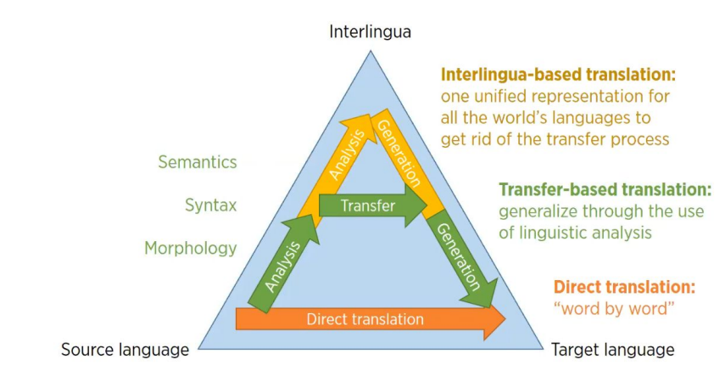
Vauquois triangle
It visualises and describes the classical approaches to machine translation, showing the evolution of those approaches. These approaches are direct translation, transfer-based translation and interlingua-based translation.

Direct translation
Use a bilingual dictionary to translate the sentence word by word. Each source word is mapped in a target word. This approach does not use any intermediate structures other than some morphological analysis. There could be some additional reordering processes that are done on the resulting target language sentence to make its structure correct.

Transfer-based translation
Determine the structure of the source sentence, and it applies rules to transfer the resulting structure to the target language parse structure based on knowledge of differences between the languages and then generates the target language sentence from this transformed structure.

Interlingua-based translation
This approach first analyses the source language sentence, represents it as an interlingua and then generates the target language sentence from this interlingua. Interlingua is a language independent representation that can be based on any representation scheme,

Translation evaluation

Source-based human evaluation 😐
Requires bilingual evaluations. In this case we need the source text and the reference and someone who is bilingual. The metrics to evaluate are adequacy, fluency and general translation quality.

Adequacy
We could see adequacy as asking questions like does the output convey the same meaning as the input sentence? and is part of the message lost added or distorted?. We can rank it on a scale from 5 (convey all meaning of the source text) to 1 (convey no meaning of the source text).

Fluency
While fluency could be questions like is the output good fluent English? And this involves both grammatical correctness and idiomatic word choices.

General translation quality
it is more difficult to distinguish between fluency errors and adequacy errors.

- We could use a single quality scale (1-5 to 0-100%)
- Or we could ask the bilingual evaluator to sees several translations (typically created by different systems) and ask to rank them

Reference-based human evaluation 😐
Requires human translators to produce reference and evaluators can be monolingual. We asks questions like how much does a machine-translated text need to be changed
(post-edited) in order to produce a high-quality translation? And we check the time spent on post-editing and the number of edit operations.

Reference-based automatic evaluation 😐
At the end we know that source-based human evaluation and reference-based human evaluation are not good because they need to use humans. It is very time consuming 🙁, not reusable 🙁 and subjective 🙁, but it is what we ultimately interested in 🙂.

On the other hand, automatic evaluation is cheap 🙂and re-usable 🙂 but also not necessarily reliable 🙁

Requires human translators to produce reference.
The basic idea is to provide a human reference translation and compute the similarity between the reference translation and machine translation output. We have different evaluations metrics such as
- Word error rate (WER): is the number of substitutions necessary + insertions + deletions all divided by the reference - length.
- Translation edit rate(TER): it is identical to WER but it introduces an additional operation that is shift, which moves a word sequence.
- BiLingual Evaluation Understudy (BLEU): compute the precision for n-grams of size 1 to 4 and add a brevity penalty (for too short translations).

There are some critiques about the reference-based automatic evaluation such as:
- Ignore relevance of words: names and core concepts should be more important than determiners
- Operate on local level: do not consider overall grammaticality of the sentence or the sentence meaning
- Scores are meaningless: are very test specific and are not really informative
- Human translators score low on BLEU: possibly because of higher variability and different word choices.

The changes that the random word taken is actually a positive one are very low
Inflection is the modification made to a word to indicate tense, number, gender or other grammatical features
The weighted sum is a selective summary of the information contained in the values, where the query determines which values to focus on
RNN are very good and we do not want to throw them away, we just want to find possible alternatives to overcome some of the problems of RNN
The red cat chased the mouse ⟹ we can see that the subject the red cat is before the verb, while the object the mouse is after, furthermore the adjective of the cat is red and it is located before the noun.
The red cat chased the mouse ⟹ red cat is something that doing the action of chasing something else.

